Article

IoT monitoring of tree ecosystem services in urban green infrastructures: possibilities and challenges

Victor Matasov 1,*, Alexey Yaroslavtsev 1,7, Giovanna Sala 1,2, Olga Fareeva 1, Ivan Seregin 1,7, Luca Belelli Marchesini 1,3, Simona Castaldi 1,4, Viacheslav Vasenev 1 and Riccardo Valentini 1,5,6

1 Department of Landscape Design and Sustainable Ecosystems, Agrarian-Technological Institute, RUDN University, Miklukho-Maklaya str., 6, 117198, Moscow, Russia;

2 Department of Agricultural and Forestry Science, University of Palermo, Viale delle Scienze, Ed. 4, 90128 Palermo, Italy;

3 Department of Sustainable Agro-ecosystems and Bioresources, Research and Innovation Centre, Fondazione Edmund Mach, San Michele all’Adige, Italy;

4 Department of Environmental, Biological and Pharmaceutical Sciences and Technologies, Campania University “Luigi Vanvitelli”, Via Vivaldi 43, 81100 Caserta, Italy;

5 Department for Innovation in Biological, Agro-Food and Forest Systems, University of Tuscia, Via S.M. in Gradi n.4, 01100 Viterbo, Italy;

6 CMCC Foundation, via Augusto Imperatore, 16, 73100 Lecce, Italy;

7 Department of ecology, Russian Timiryazev State Agrarian University, Moscow, Russia;

**\*** Correspondence: matasov-vm@pfur.ru;

Received: date; Accepted: date; Published: date

**Abstract.**

Urban green spaces play an essential role in the sustainable functioning of urban ecosystems and provide the most important regulating and cultural ecosystem services. Meanwhile cities are entering a new age of widespread data collection, processing, and utilization in urban decision-making. It is necessary to expand the uses of digital and computing technologies to green infrastructure management, as it is a crucial component for human well-being under the rapid urbanization.

The Bolotnaya square – small green area (370m length and 120m width) situated on the island Balchug in the center of Moscow – was chosen as a study site that represents urban green infrastructure under the high influence of urban heat island and high level of anthropogenic load. . For real-time monitoring sixteen TreeTalkers that provide data on physiological conditions of a single tree were installed to describe different species in their local conditions. All measurements were conducted from 1 July to 31 November with 1.5 hour time resolution. We used R programming language for all data processing. To move from parameters of trees functioning to provided ecosystem services we established several indicators related to climate, air and water regulation.

Our results show that the average tree in Moscow center during investigated period reduced extreme heat on 2℃ degree and cooled down the area by consuming energy on 4900KWh, transpires 160 mmof precipitation water, deposits 12 kg of Carbon and absorbs 4.5 kg of PM10. But the real values for different species vary (up to five-ten times) under the influence of local conditions and also depends substantially on seasonal and weather changes. Thus, it is crucial to use real-time monitoring data to understand deeper the processes in urban forests. There is a new opportunity of applying IoT technology not only to measure the functioning fluxes, but to establish a smart urban green infrastructure management based on ecosystem services indicators.

**Key words**: Ecosystem services, Ecological engineering, Green infrastructure, Real-time monitoring, Smart cities, Sustainability, TreeTalker, Trees, Urban forests.

**1. Introduction**

Urbanization is increasing on a global scale, and today more than half of the world's population lives in cities and more than two thirds are expected to live in cities by 2050 (Dye, 2008). Concentration of population in cities plays a significant role in fostering economic development and encouraging innovation due to economies of scale (Bettencourt et al., 2007). In addition this process may also have negative effects on many aspects of human well-being, including increasing crime rates (Bettencourt et al., 2007) and growing health risks (Frumkin, 2003; Lederbogen et al., 2011). Moreover, it was shown that urban areas significantly contribute to climate change and global carbon emissions, ecosystem degradation and biodiversity loss on a global scale (Grimm et al., 2008; Seto et al., 2012). It is well-known that people living in urban areas depend on natural ecosystems not only within the city limits, but also beyond the urban area (Bolund and Hunhammar, 1999) thus demands on natural capital and ecosystems services keep increasing steadily (Guo et al., 2010; Krausmann et al., 2018).

The ecosystem services (ES) concept, which emerged from ecological economics in 1990s, allows to understand and explain human-environmental interactions complexity if we want to balance interlinked sustainable goals in landscape planning (Vihervaara et al., 2019; Wilkinson et al., 2013). It is widely discussed that ES concept could be used as a new Esperanto (Spyra et al., 2019) because of its communicative power in participatory planning processes (Haaren et al., 2019; Opdam et al., 2018). But such comprehensive planning approach requires planners to assess and value nature’s contributions to the human well-being (Gómez-Baggethun and Barton, 2013; UNEP, 2010), especially in a cities as a coupled human-environment systems (Wu, 2013). The concept of ES and its application to urban environments were addressed by major initiatives like the Millennium Ecosystem Assessment and The Economics of Ecosystems and Biodiversity, and have gained increasing attention in literature (Bolund and Hunhammar, 1999; Haase et al., 2014; Kremer et al., 2016) and in a policy debate on green infrastructure (Burkhard et al., 2018). However, ES concept might be too complex and sometimes does not meet the real world and requirements for planning applications, and even might be misinterpreted in practice (Czúcz et al., 2018; La Rosa et al., 2016; Luederitz et al., 2015). It is common situation when decision-makers pay attention to visible and directly usable ES, which are mainly provisional and cultural ES and underestimate the value of regulating and habitat ES (Mascarenhas et al., 2016; van Oudenhoven et al., 2018; Wissen Hayek et al., 2016).

Urban green infrastructure (UGI) play an essential role in the sustainable functioning of urban ecosystems and provide the most important regulating and habitat ecosystem services such as carbon sequestration, microclimate formation, pollution and dust reduction in atmospheric air, water balance control, wildlife habitat, wind and noise reduction, etc. (Andersson et al., 2014; Gómez-Baggethun and Barton, 2013; Lovell and Taylor, 2013). The magnitude of the ES provided depend on the characteristics of UGI, such as vegetation type, age, structure and management practices, which is important compare to natural ecosystems. This may cause a trade-off between which service is maximized (Bodnaruk et al., 2017), or between ecosystem services and disservices (Speak et al., 2018; Teixeira et al., 2019) and could be a reason for cost-benefit analysis (Song et al., 2018; von Döhren and Haase, 2019). There are several studies that assess ES in different types of UGI (Blanusa et al., 2019; Lovell and Taylor, 2013; Nowak et al., 2006), in areas with the same typology but different types of management (Lilly et al., 2015; Schwilch et al., 2018) or in different types of vegetation within the same area (Mexia et al., 2018). Several types of models identify ES via proxies, typically land-use/cover, based on expert knowledge and causal relationships (Neugarten et al., 2018). Urban ES assessing presents a special case due to the high, fine-resolution spatial heterogeneity of these landscapes that could lead to high mapping error (Zhao and Sander, 2018). That is why to better understand the ES provided by UGI researchers conducted direct measurements of different processes (Nowak et al., 2006; Nowak and Crane, 2002), and its modeling (Lin et al., 2019; Rötzer et al., 2019) on a tree-level, which yielded in wide spreading use of software and tools, such as i-Tree model (<http://www.itreetools.org>).

Our understanding of the relationships between functional fluxes in ecosystems and services they provide is still very incomplete (Drobnik et al., 2018; Van Reeth, 2013). To overcome this high complexity in human-environmental systems scientists use ecological indicators that generally are variables that provide aggregated information on certain phenomena (Müller and Burkhard, 2012). For the ES assessment the importance of developing appropriate indicators has been recognized (Burkhard et al., 2018; van Oudenhoven et al., 2018) and many ES indicators have been developed, applied, tested and reviewed (Gómez-Baggethun and Barton, 2013; La Rosa et al., 2016; Wissen Hayek et al., 2016). ES indicators need to be relevant to specific purpose (e.g. to reflect difference in land management - van Oudenhoven et al. 2012) or component (e.g. soils - Andrea et al. 2018; Drobnik et al. 2018) or spatial-temporal scale (Aalders and Stanik, 2019; Norton et al., 2016) to avoid uncertainties from that side, but at the same time ES indicators should inform decision making (Czúcz et al., 2018; Willcock et al., 2016). It’s completely clear for decision-makers that “you cannot manage what you do not measure”, thus these indicators should be linked to measurable policy targets and should help to monitor policy progress. And from another side we see a growing interest from citizens to the widespread measurements of the environmental conditions they are living in (Njue et al., 2019; Schröter et al., 2017), so it is also necessary to create clearly understandable indicators for involving people. We should also take into account fast development of cutting-edge technologies of observation, modeling, computing and even acting in a new Industry 4.0 world (Nitoslawski et al., 2019).

The widespread integration into the urban environment of Information and Communication Technologies (ICTs) and Internet of Things (IoT) tools makes our cities “smart” (Albino et al., 2015). Smart technologies are already being applied in environmental management. The species and structure of individual trees was mapped and assessed with remote sensing, aided by machine learning (Alonzo et al., 2014). Forest regeneration was assisted by drones or unmanned aerial vehicles (UAVs) through surveying, fertilizer spraying, and precision aerial seeding (Elliott, 2016). Wireless sensor networks have been deployed in greenhouse settings to measure and regulate environmental parameters (Bauer et al., 2019; Mesas-Carrascosa et al., 2015). Acoustic sensors were used to assess the urban noise pollution (Farina et al., 2014; Mydlarz et al., 2019). The huge data collected through these technologies provide more insight into the UGI and can be used in analysis, modeling, and prediction (Kitchin, 2014). Traditional monitoring methods do not allow assessing the state of UGI with the spatial-temporal resolution needed for the diagnosis of stressful situations and for decision-making on the management and development of an urban environment. Such new smart digital technologies can be used as tools to improve the human well-being through balancing the ES provided by UGI. The use of wireless network sensors and data loggers can provide information about environmental parameters at a local scale and its visualization in real time (Kitchin, 2014; Nitoslawski et al., 2019).

So, the aim of this work was to show the possibilities and discuss the challenges of real-time tree-level monitoring of ecosystem services in urban conditions. We focused on next objectives:

1) test the real-time monitoring technology by measuring trees functioning parameters in different conditions,

2) justify the indicators that can be useful to interpret measurements in terms of ecosystem services,

3) analyze local factors influencing ecosystem services provisioning.

**2. Materials and Methods.**

2.1. Study site and installations

With a population of over 12 million people, Moscow is the largest metropolis in Europe. The territory of the Moscow metropolis is located in the center of the East European Plain and has a temperate continental climate. The typical vegetation, including species characteristic of the South Taiga zone, has been preserved mainly in specially protected natural areas, while a significant part of green infrastructure is represented by introduced species: linden, maple, willow, ornamental forms of trees and shrubs. The New Moscow Development Project, adopted in 2012, has started active urbanization on an area of more than 1,500 km2, the impact of which on soils and ecosystems is already visible (Vasenev et al., 2019) and will only increase in the future.

Bolotnaya square is a small green area (370m length and 120m width) situated on the island Balchug in the center of Moscow (Figure1), 600m to the south from the Kremlin. Now it’s became well-known through meetings of political opposition. This site located only 700m to the west from Balchug meteorological station that provided data each 3 hours. Study area represents urban green infrastructure under the high influence of urban heat island and high level of anthropogenic load. The main works on its improvement (tree planting) were completed by 1948. So, it was possible to analyze the influence of local biotic factors (species, height, local neighborhood standing conditions, age).

Figure1. Study area.

TreeTalker+ (TT+) devices were installed on the 16 trees: 5 on *Acer platanoides* (average DBH 38.7 cm), 3 on *Betula pendula* (average DBH 21.8 cm), 3 on *Larix sibirica* (average DBH 32.1 cm) and 5 on *Tillia cordata* (average DBH 34.1 cm). During the first observation all trees were characterized by height, diameter, age group, VTA score, (ranging from 1 (healthy conditions) to 6 (severe decline) and standing type (table 1).

Table 1. Basic characteristics of the trees.

|  |  |  |  |  |  |  |  |
| --- | --- | --- | --- | --- | --- | --- | --- |
| **Tree ID** | **Species** | **Height, m** | **Diameter, cm** | **Age** | **Canopy area, m2** | **Standing type** | **VTA score** |
| 218A0281 | *Acer platanoides* | 14 | 45.83 | 50-60 | 35.8 | Inner group | 4 |
| 218A0077 | *Acer platanoides* | 20 | 35.65 | 50-60 | 55.7 | Inner group | 2 |
| 218A0262 | *Acer platanoides* | 14 | 34.69 | 50-60 | 28.5 | Edge group | 1 |
| 218A0255 | *Acer platanoides* | 21 | 34.37 | 50-60 | 55.3 | Inner group | 2 |
| 218A0212 | *Acer platanoides* | 15 | 33.74 | 50-60 | 27.6 | Inner group | 3 |
| 218A0285 | *Betula pendula* | 11 | 23.87 | 50-60 | 8.2 | Inner single | 1 |
| 218A0104 | *Betula pendula* | 11 | 21.65 | 30-40 | 7.6 | Inner group | 1 |
| 218A0210 | *Betula pendula* | 11 | 21.00 | 30-40 | 6.4 | Inner group | 1 |
| 218A0138 | *Larix sibirica* | 19 | 40.74 | 80-100 | 37.4 | Inner group | 2 |
| 218A0079 | *Larix sibirica* | 25 | 32.14 | 80-100 | 65.9 | Inner group | 3 |
| 218A0277 | *Larix sibirica* | 24 | 26.10 | 80-100 | 32.3 | Inner group | 2 |
| 218A0186 | *Tilia cordata* | 17 | 40.42 | 50-60 | 19.5 | Edge group | 3 |
| 218A0121 | *Tilia cordata* | 16 | 37.87 | 50-60 | 31.3 | Inner group | 1 |
| 218A0153 | *Tilia cordata* | 14 | 35.33 | 40-50 | 21.1 | Edge group | 2 |
| 218A0111 | *Tilia cordata* | 12 | 28.01 | 40-50 | 20 | Edge group | 3 |
| 218A0270 | *Tilia cordata* | 11 | 25.14 | 30-40 | 22.4 | Inner single | 3 |

The TreeTalkers devices (TT+) (Nature4.0 BC URL: www.nature4.org, Valentini et al. 2019) are microprocessor based IoT platform built around the ATMEL328 chip, equipped with a LoRa transceiver for radio transmission to a central gateway which collect the individual tree data and send to cloud using GSM/GPRS technology. The TT+ sensors are able to measure: 1) the sap flow density, using a transient thermal dissipation methods based on an heating/cooling cycle of 10minutes every 1 hour (Do et al., 2018), 2) the light transmission spectra through the canopy in 12 spectral bands , using 2 spectrometers (VIS and NIR), 3) diameter growth with an optical IR pulsed device, 4) Stem position and oscillation in 3 axis with an on board accelerometer. In addition air temperature and humidity is recorded at the single tree level. Specifications are listed in Table 2.

Table 2. Measured parameters according to TT+ specification.

|  |  |  |
| --- | --- | --- |
| **Sensor** | **Range** | **Accuracy** |
| Accelerometer | 0-360° (0-8g) | ± 0.01° |
| Diameter growth sensor | 0-1 cm | ±200  |
| Temperature probes | -40 ÷ +40 °C | ±0.1 °C |
| Stem humidity probe | 0 – 100% | ± 2% v/v |
| Visible Spectrometer | 400-700 nm | ± 5 nm peak  ± 20 nmHBW  (450,500,550,570,600,650 nm) |
| Near-Infrared Spectrometer | 700- 900 nm | ± 5 nm peak  ± 10 nmHBW  (610,680,730,760,810,860 nm) |
| Air and humidity sensor | -10 ÷ +85  0-100% | ± 0.5 °C  ± 5% |

A reference device TT+ (TT-R) was mounted outside of the tree canopies to collect climate data and incoming solar radiation reference spectra. On individual trees, the devices were placed at a height of 3 m from the ground on the north side of the trunk and the batteries - on the south side, which reduces the risk of damage or theft of devices. All measurements were conducted from 01 July till 31 November with 1.5 hour temporal resolution.

2.2. Justification of the ES Indicators.

There is a wide range of existing ES indicators, thus we have tried to choose from existed literature (Andersson-Sköld et al., 2018; Gómez-Baggethun and Barton, 2013) the ones that can be directly estimated by our measured parameters. The ES indicators and the relative measured vatiables, including algorithms references are shown on table 3. Direct measurements (like air temperature or relative humidity) gave us an opportunity to calculate ESI without any additional assumptions. However all the ESI that is labeled as “indirect” required us to introduce some adjustment factors or assumptions. Several ESI could be calculated easily via using LAI, but not for all of them we had enough information (e.g. gas concentrations in the air or noise level) and possibilities to verify the results, so we decided to show only LAI dynamics instead of providing absolute values. We present particulate adsorption as an example of usefulness of LAI indicator indirect use.

Table 3. Indicators of ES, provided by urban trees

|  |  |  |  |  |  |  |
| --- | --- | --- | --- | --- | --- | --- |
| **ES group** | **Type of ES** | **Indicator** | **Sensor** | **Type of equation** | **Units** | **Key references** |
| Global Climate regulation | Carbon sequestration | Tree growth rate | IR growth sensor | Indirect | kg C | (Gratani and Varone, 2006; Lindén et al., 2020; Nowak and Crane, 2002) |
| Local Climate regulation | Climate comfort regulation | Air temperature | Thermo-hygrometer | Direct | C degrees | Land surface temperature and climate comfort level (Krayenhoff et al., 2020; Marando et al., 2019; Morakinyo et al., 2020) |
| Humidity | Thermo-hygrometer | Direct | % | Humidity control (Chen et al., 2019; Moghbel and Erfanian Salim, 2017) |
| Wind velocity | Spectrometer | Proxy  ~LAI | m s-1 | Wind comfort level (Hefny Salim et al., 2015; Kang et al., 2020; Lee et al., 2010) |
| Energy balance regulation | Latent energy via transpiration | Thermo-hygrometer probes | Indirect | W m-2 | Exergy (Puzachenko et al., 2013, 2014), Energy balance (Krayenhoff et al., 2020) |
| Water regulation | Run-off mitigation | Evapotranspiration | Thermo-hygrometer probes | Indirect | l hr-1 or mm | (Chen et al., 2019; Marchionni et al., 2019; Urban et al., 2019; Zölch et al., 2017) |
| Rain buffer | Spectrometer | Proxy  ~LAI | % | Rainfall buffer (Pereira et al., 2009; Smets et al., 2019; Valente et al., 2020) |
| Air quality regulation | Particulate adsorption | PM removal | Spectrometer | Indirect | g m-2 | (Hirabayashi et al., 2012; Nowak et al., 2018, 2006; Sæbø et al., 2012) |
| Gas regulation | Gas removal | Spectrometer | Indirect ~LAI | g m-2 |
| Human health regulation | Acoustic environment regulation | Noise reduction | Spectrometer | Proxy  ~LAI | % | (Martens and Michelsen, 1981; Van Renterghem, 2014; Yang et al., 2013) |

*2.2.1. Carbon sequestration*

Carbon sequestration assessment was based on IPCC 2006 approach utilizing biomass expansion factors (BEF):

|  |  |
| --- | --- |
| ΔC = [ΔV * BCEF] * (1 + R) * CF, | (1) |

where BCEF = BEF * D and R (root to shot ratio) was taken from literature according to species and age of the tree (Schepaschenko et al., 2018), CF (biomass conversion into carbon) was taken as 0.5. Trunk volume was calculated using height measured directly in field and basal area increment(BAI according to LeBlanc, 1992).

Where *w* is trunk diameter expansion measured in real time with TreeTalker+ IR distance sensor. Species dendrometric coefficients have been taking into account for the estimation of the trunk shape in the final calculation of biomass increment.

*2.2.2. Climate regulation via air temperature and humidity*

We have used direct measurements of temperature and humidity changes based on the difference between data form thermo-hygrometers of individual TT, measuring climate parameters at 3.5 m height under the crown space and TT-R (reference outside station).

*2.2.3. Energy consumption through transpiration*

And the energy absorbed by tree is the result of this equation:

|  |  |
| --- | --- |
| L= E, | (2) |

where E is energy spent in transpiration ( the latent heat for vaporization of water = 2264.705 KJ/Kg), E – evapotranspiration, which was assumed equal to sap flow.

*2.2.4. Run-off mitigation via transpiration*

Each TT+ has two heat dissipation sensors (Granier 1985) which was installed into the tree trunk at the vertical and horizontal distance 10 cm. Sensor has diameter 3mm each and was installed at the depth 3cm. TT+ heat dissipation sensors on all trees was installed on the northern side of the trunk at the 3.5m height and was well protected from direct sun heating by canopy. All sensors data was collected by TT+ at 10 min intervals and sent to server every 90 minutes.

Sap flow density at 90-minutes intervals was calculated according to Granier’s ΔTmax approach – maximum difference between heated and reference sensor was associated with minimal flow condition. Sap wood area for each tree was assessed according to couple of stem wood cores taken from each tree. Sap flow was calculated with assumption that the whole trunk sapwood area was conducting water. It was assumed that daily transpiration is equal to daily sum of sap flow. Transpiration was normalized to each tree canopy area and compared with precipitation from closest meteorological station.

*2.2.5. LAI*

There are a lot of different methods and protocols to estimate LAI (X. Wang et al., 2019; Yan et al., 2019). According to Monsi and Saeki (1953) light transmission through canopy as porous media can be treated according to the Beers law. In this way LAI can be estimated by the extinction of photosynthetic light radiation through the canopy (Neinavaz et al., 2016). Photosynthetically active radiation was measured above and below canopy (with TT-R and TT+ spectrometers, respectively). Since the light is blocked also by woody components of canopy (i.e. branches and twigs), the extinction of light profile gives the PAI (Plant Area Index) as follow:

|  |  |
| --- | --- |
| . | (5) |

PAI consists of wood area index (WAI) and leaf area index (LAI). Assuming that WAI constant throughout vegetation period and LAI = 0 after defoliation (second part of October and November), WAI for each tree was calculated as mean PAI of November*.* Light extinction coefficient k was calculated per each species utilizing direct LAI measurement with litter traps.

*2.2.6. Particulate adsorption*

Dry deposition of solid particles on canopy was calculated according to i-Tree Eco Dry Deposition Model (Hirabayashi et al., 2012):

|  |  |
| --- | --- |
| Pads=Vd*C | (6) |

where C is the PM10 concentration (g m-3), Vd the velocity of deposition (m s-1), LAIPM10  the leaf area index for pollutant deposition (m2m-2) and VdPM10max,VdPM10avg,VdPM10min  – maximum, average and minimum deposition velocity for PM10 – 0.0064 ms-1, 0.0025 ms-1, 0.01 ms-1, respectively. Values were multiply by canopy area to show adsorption per individual tree. Pollutant concentration was obtained from nearby open access pm10 sensors via sensor.community web portal (<https://sensor.community/en/>).

2.3. Data processing.

Data collection with TreeTalker+ devices is organized according to the following scheme. All types of devices (TT+ and TT-R) made measurement every 90 minutes, stored data in internal memory, then according to predefined time window transmitted data to TT-cloud device via Low Power Wide Area Network (LoRaWan) wireless networking protocol. TT-cloud device is a gateway device in TreeTalkers devices ecosystem, which purpose is to collect data from all TT devices on site, store it and then transmit it to online database via WiFi or wireless mobile networks.

All remote data was collected and processed with R computing language (R Core Team, 2014). Field data was organized in a table and added to computation on early stages of processing. All weekly measured parameters were filtered by excluding 3 sigma (standard deviation) data. Filtered data was linearly interpolated. Data from TT devices didn’t have gaps more than three days (battery problems), big gaps were filled with data from trees with closest parameters (species, trunk diameter, height, canopy size, position on site).

**3. Results and its discussion.**

* 1. Carbon sequestration.

Carbon sequestration is the result of continuous diameter increment across the season, using the biomass equation with expansion factors. The growth dynamics show biomass increase till the end of September (around 260 day of a year) due to the warm autumn (Figure 2). Betula’s growing decreased two weeks later than others, with less variabulity across individuals, possibly because of more uniform young age. Acer #218A0281 had different dynamics with a rapid growth in the begginnig of the investigated period and then stopped growimg a month and a half earlier than others. This particular tree also showed the lowest VTA score, indicating possible declining patterns.

In total the average accumalated carbon (during half of the vegetational season) was around 15 kg C for Acer spp. Larix accumalated about 7.5 kg C in average, and the lowest level was shown by Betula – 3 kg C. The most diverse was Tillia – from 5 to 20 kg C that was related to the age and diameter. So, it is clear that diameter of the tree influence greatly the growth ratio and carbon sequestration as well.

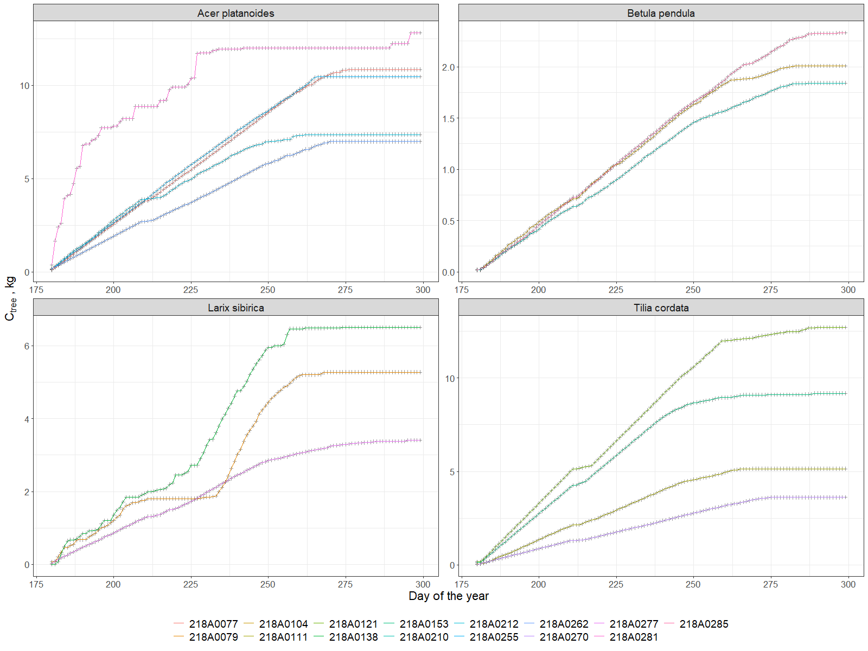

Figure 2. Carbon accumulation for each tree.

In general our knowledge of street tree carbon dynamics, including the balance of growth, mortality, and planting rates is quite data limited (Nowak et al. 2004). Although the carbon stock of the urban green is smaller compared to natural forests, the storage capacity is considerable (Moser et al., 2018). Growth rates of urban trees may be accelerated by the heat island effect, as result of increasing temperature, longer growing season and potentially higher N deposition, as it was shown by Pretzsch et al. (2017). The observed diameter growth for the different species, although is rather variable across individuals, are consistent with the existing literature, showing for Picea and Birch a range of 1-3 mm of annul growth (Augustaitis et al., 2018, 2015) in the same age range. Conversion of diameter growth in biomass and hence carbon sequestration is very much related with the BEF coeffcients which we have derived by (Schepaschenko et al., 2018), specifically from Russian environment. One of the most comprehensive study on urban tree carbon sequestration is the one of Nowak et al. (2013) across a wide range of US cities. He showed an average annual net carbon uptake per tree of about 0.226 m-2 year-1. Scaling larch trees carbon sequestration per unit of crown area we obtain an average value of 0.14±0.04 kg C m2 per half of vegetation period, which is a closest result, while for broad leaved species this paramater was more than two times higher (with max of 0.48±0.14 kg C m2 per half of vegetation period for *Acer platanoides*). .

* 1. Air Temperature and Humidity control.

The local climate control from ecosystem service perspective is the mitigation of extreme temperatures and providing comfort urban microclimate. In fig. 3 the diurnal difference mean changes of temperature between the reference station and the within tree crown space is presented as mean monthly day, for the investigated species. During the day the temperature difference is maximal, peaking on early afternoon in July, August and September, with the contrasting difference of October when the dynamic is reverted. During the day trees are cooling the surrounding air, showing an effect up to about 2°C degrees with the external temperatures. In October all the species show a warming effect at mid of the day, on the same order. An opposed behavior is recorded for nighttime periods where usually during summer months trees are slightly warmer than the surrounded air. In October they show a cooling effect in the night.

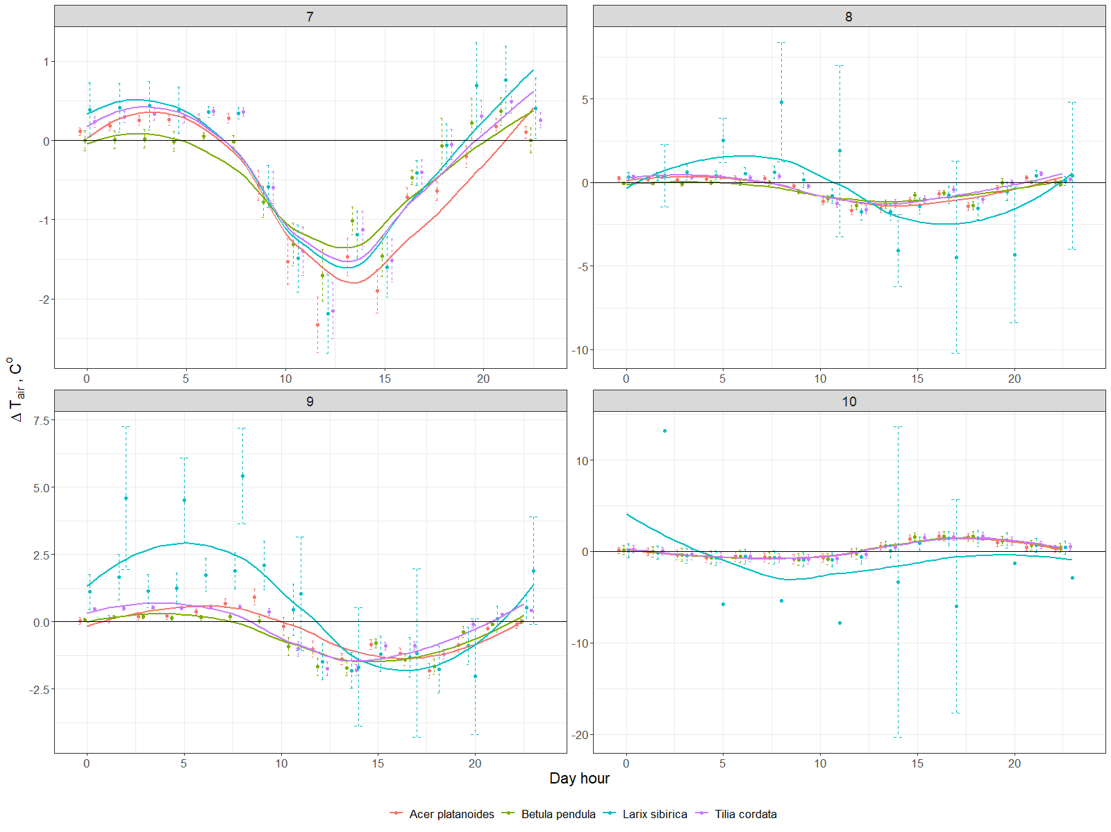

Figure 3. Diurnal differences mean changes of temperature by month

The average differences between the air relative humidity under and outside of the canopy were not more than 20% (annex 1). During daytime trees made air more humid, while during nights they reduced humidity. There were no seasonal changes through months, even no significant difference between species. We can only see the typical sinusoid line with delay in time as a result of transpiration process.

Another important effect of trees is the mitigation of climate extremes. For this purpose we have estimated the daily differences between maximum and minimum temperatures of the reference station and the individual tree recording (fig. 4). While temperature amplitudes outside of the canopy (the black line) reached a maximum of about 10°C degrees in August, under the canopy this amplitude was 3°C degrees lower. All the species showed similar dynamics through the investigated period, but under the larch temperature extremes were more similar to the reference station particularly during fall after defoliation and due to the decrease of the air temperature.

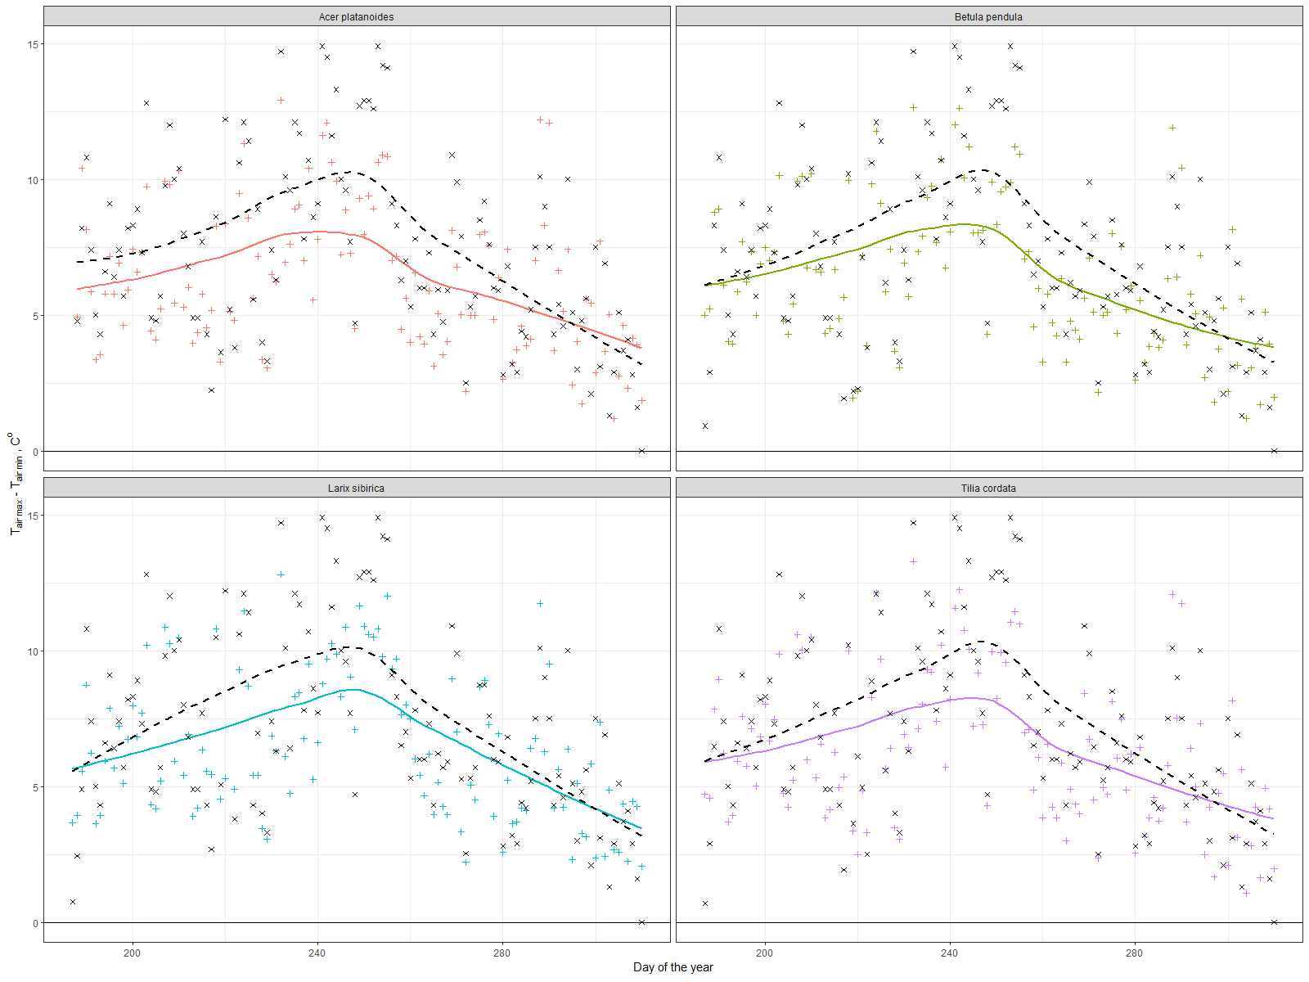

Figure 4. Daily maximum amplitude differences between TT-R (black line) and TT+

These findings correspond well to Chen et al. (2019), who explained observed seasonal dynamics of temperature reduction rates by differences in transpiration and to Rahman et al. (2020), who also found that within the canopy radius of 4.5m of Acer platanoides or Tilia cordata trees, daytime temperature decreased up to 3.5 ℃ during August in comparison of the unshaded surrounding area. Our results go in a line with the meta-analysis study, which showed relations between individual tree characteristics and daily/seasonal temperature reduction dynamics in different climate and urban conditions (Rahman et al., 2020). Temperature reduction by urban green infrastructure on about 0.5-2.5℃ degrees was also shown in several articles, which used computational modeling (Buccolieri et al., 2019; Morakinyo et al., 2020) and satellite based data such as land surface temperature (Kremer et al., 2016; Tonyaloğlu, 2020).

* 1. Energy consumption by trees via transpiration

In figure 5 we show an ensemble of transpiration daily patterns for the investigated individuals which show the typical diurnal behavior modulated by changing environmental parameters.

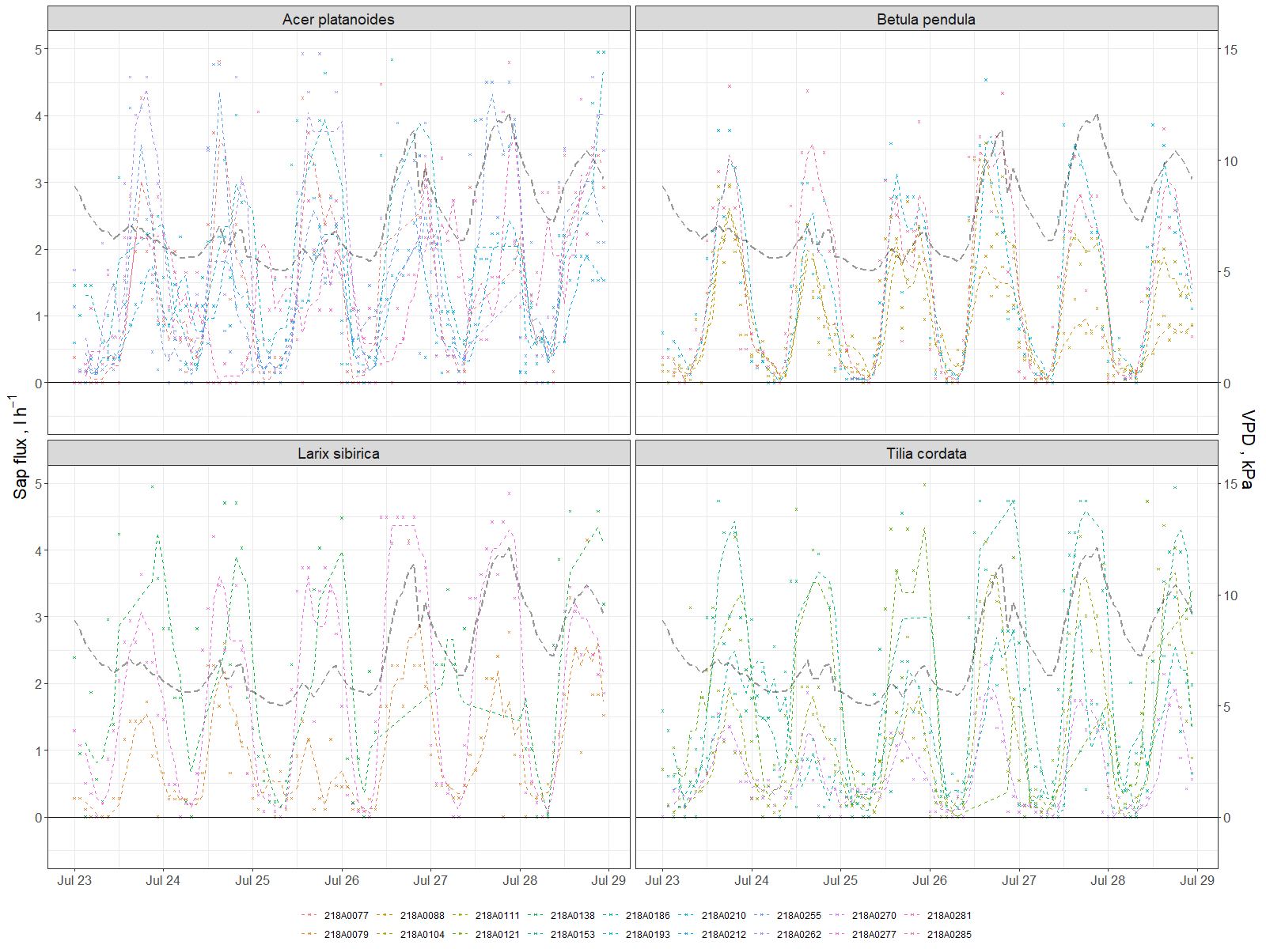

Figure 5 Sap flux and VPD dynamics for several days during inversigated period.

Using the energy balance equation it is possible to estimate the amount of absorbed radiation that is subtracted from the environment for transpiration. Diurnal graph shows the increase of the absorbed latent heat (L) during day-time when evapotranspiration starts following the sun rise (fig.6).

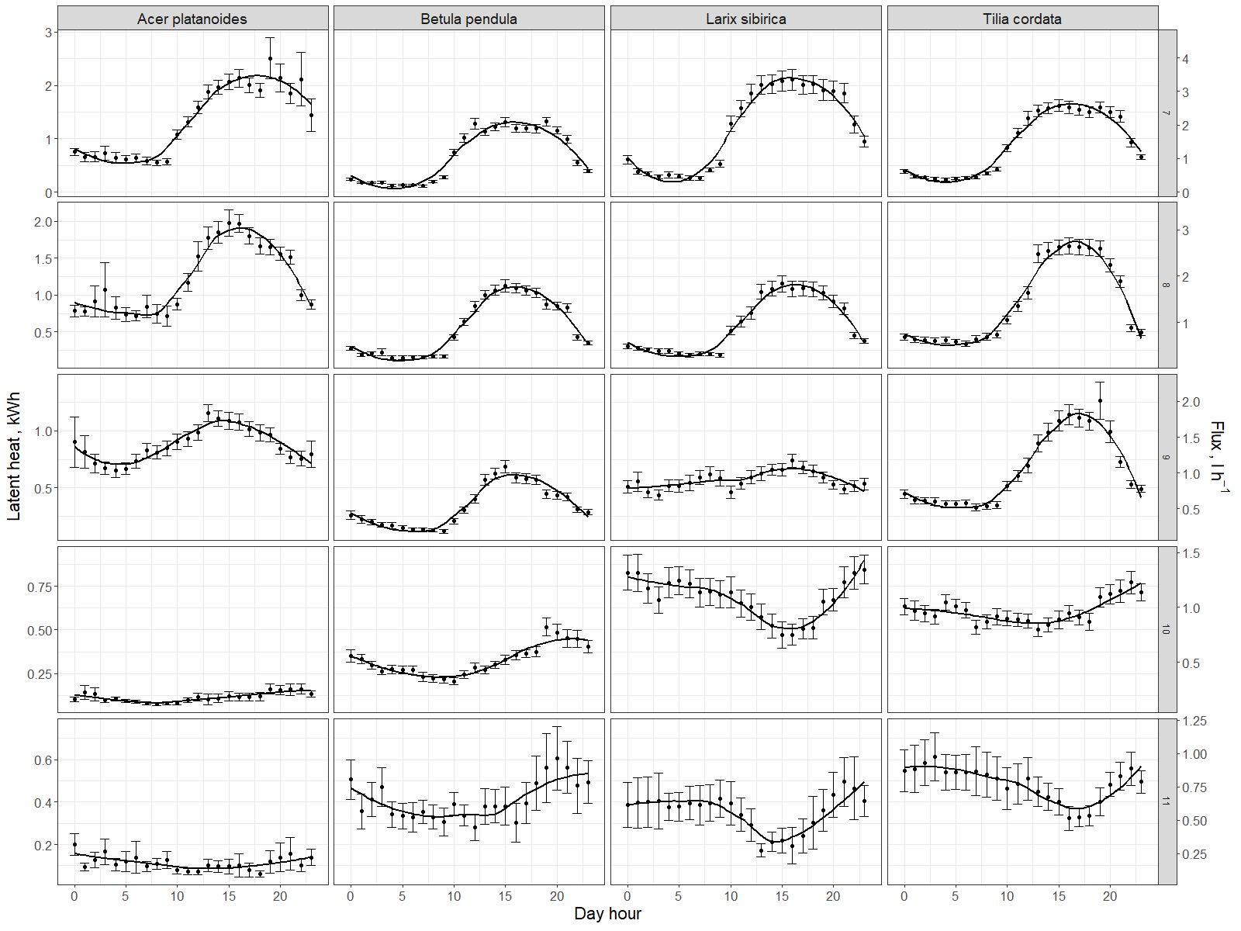

Figure 6. Diurnal dynamics of Latent heat (L) and sap flow for different species averaged per month

Also the differences between individuals are noticeable (fig.7). For example Acer #218A0281 showed completely different energy balance structure than other Acers and very low total value during summer months, that can possibly by explain by his lowest VTA score. Acer #218A0262 was overheated during autumn months that can be related to his edge standing position on the southern border of the green area.

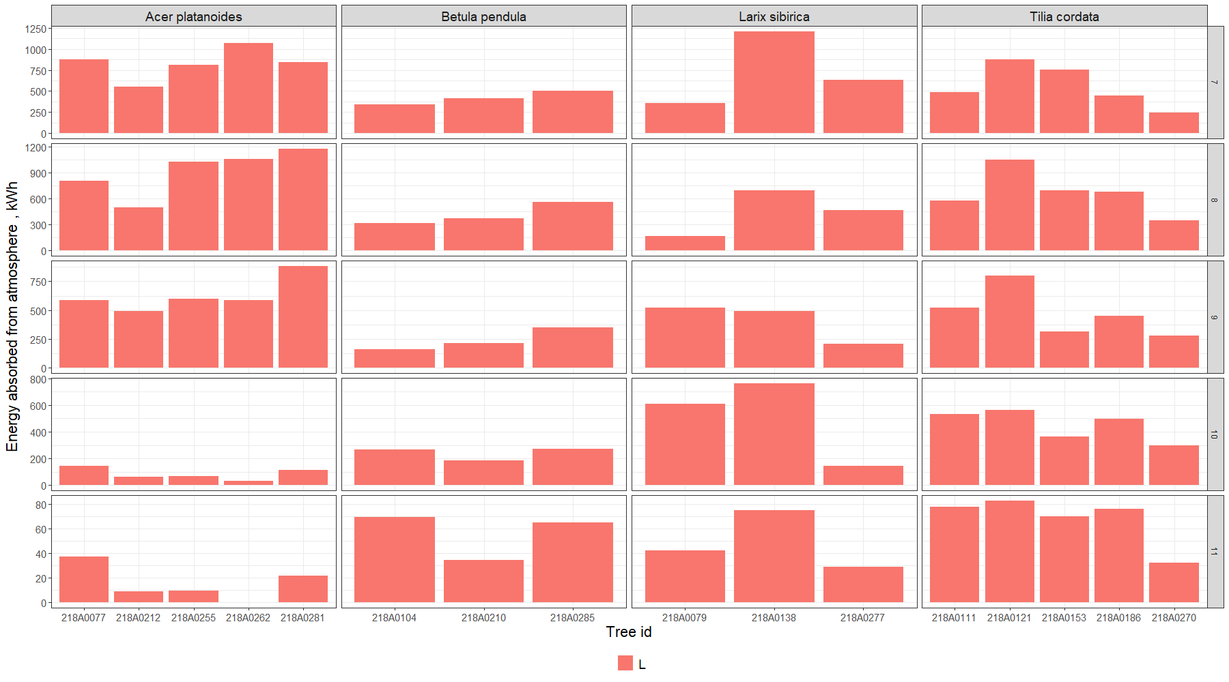

Figure 7. Energy removed from atmosphere monthly by each investigated tree

Trees energy losses had high variation between species, individual trees and seasons. Authors possess that main variability between individual trees was due to difference in size of the canopy and position of the tree in the plot. Nevertheless, there are not much publication about energy balance of boreal urban trees, we got comparable number for lime in summer months. (Moser et al., 2015).

* 1. Run-off mitigation by trees via transpiration

For the purpose of the current study we report the cumulated transpired amount of water in relation to seasonal rainfall. The units are expressed in mm of water where for each of the tree, transpiration rates have been converted in mm by using the tree canopy area (fig.8). The main purpose is to show, from ecosystem services perspective, the possibility of a tree to serve as a sewage system to mitigate flooding from rains. Our results show that maple and lime trees reduced 130 (+-50) mm of water through the investigated period, larch trees around 90 (+-50) mm, while young birch– about 300 (+-50) mm. In general, this cumulative process was mostly linear with some differences in rates that can be associated with different VTA scores and standing conditions (e.g. Acer #262 stands on the edge under a higher anthropogenic pressure, thus slowed down transpiration on 290th DOY). On the other hand there were no significant respond to the heavy rains.

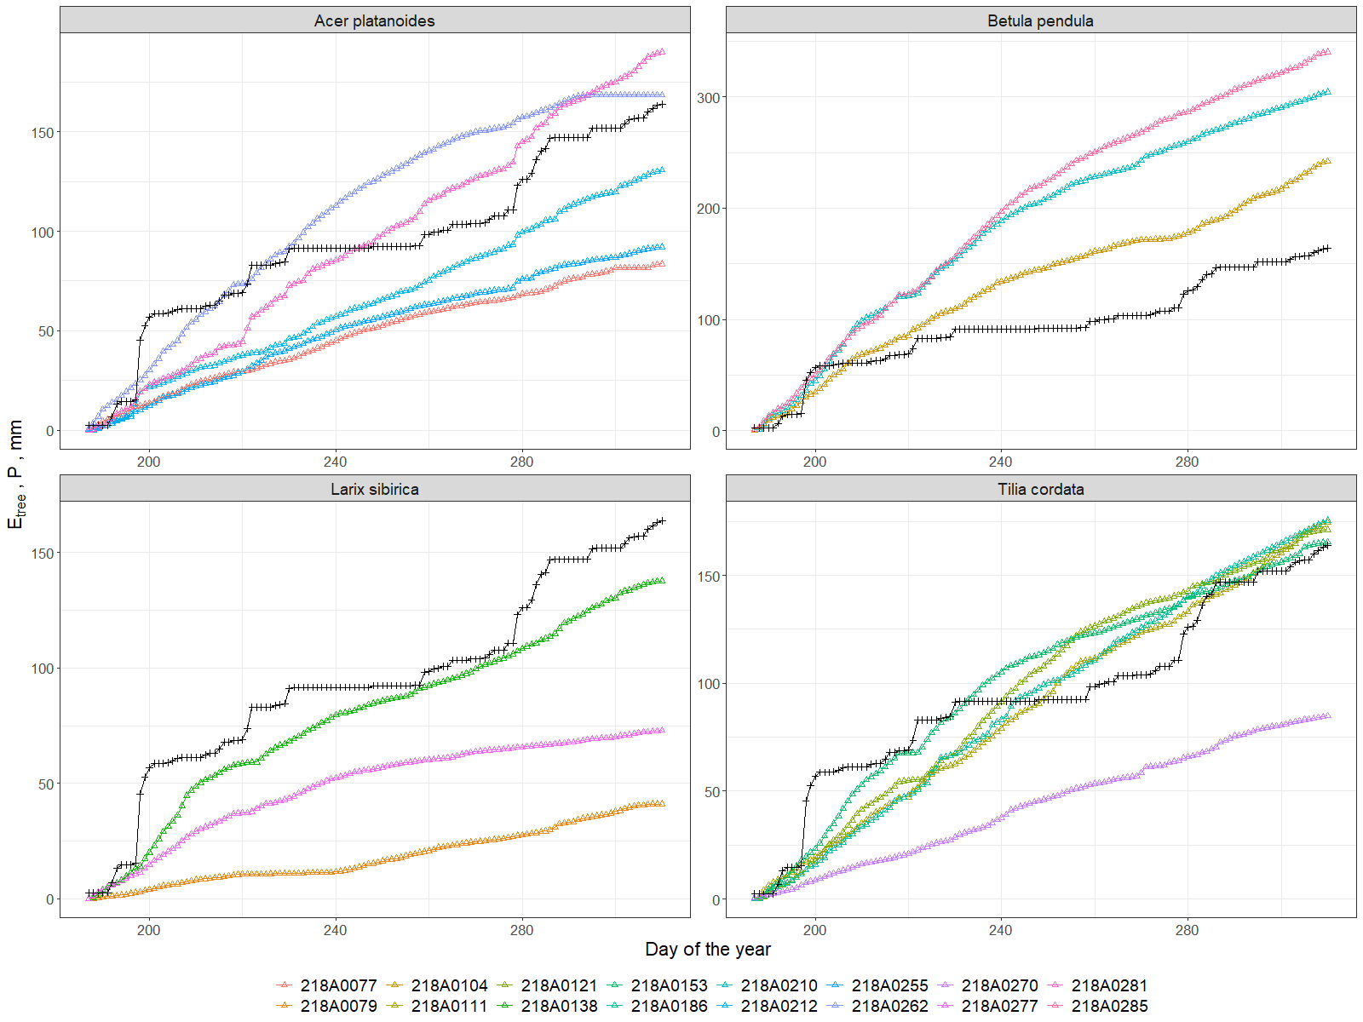

Figure 8. Evapotranspiration of each tree compared to precipitation (black line).

Our data shows that in general we can say that about 80% (+-60) of water coming with the rains can be removed thanks to tree transpiration. For investigated period individual trees was able to transpire all precipitated water volume around them in area from 20 (*Betula pendula*) to 70m2 (*Acer platanoides*), which positively correlates with size and density of those species canopies. Taking into account density of the stand it can be assumed that for investigated plot annual rainfall and transpiration could be close for years without extreme rainfall ranges, what was shown for boreal urban trees of other cities (Marchionni et al., 2019; Zölch et al., 2017). Such information obtained real time could considerably contribute to cities stormwater management (Livesley et al., 2016; Scharenbroch et al., 2016; Xiao and McPherson, 2016). It is widely discussed that rain interception for run-off mitigation consists from several important parts, e.g. leaf buffering during heavy rains (Prasad Ghimire et al., 2017; Syrbe et al., 2018; Valente et al., 2020), which is also based on leaf area index.

* 1. LAI as a proxy for several ES

The LAI dynamics is very important since it is a good proxy for several types of Ecosystem Services, such as wind velocity and noise reduction, pollution regulation and erosion protection via leaves as a buffer. Our results show that we can calculate summative canopy area index (PAI) that is just a sum from leaves and wood (bark) from the spectrometer data. Thus, due to the period with and without leaves we successfully obtained both indexes. These periods are clearly visible on a graph, and we can easily distinguish the time of defoliation which lasted one week in first days of October (fig.9). It is interesting to note that for an individual tree this process can take in reality one-two days. Only due to our perception of green areas as a whole we think this process has a slower dynamics. As a result PAI of all trees (table 4) was on average about 4 with less variation of Betula (3.0-3.2) and similar for Acer and Tillia (3-4). And even for Larix it was the same (3.4-3.7) despite our expectations; it can be possibly explain again with the higher insertion of the crown.

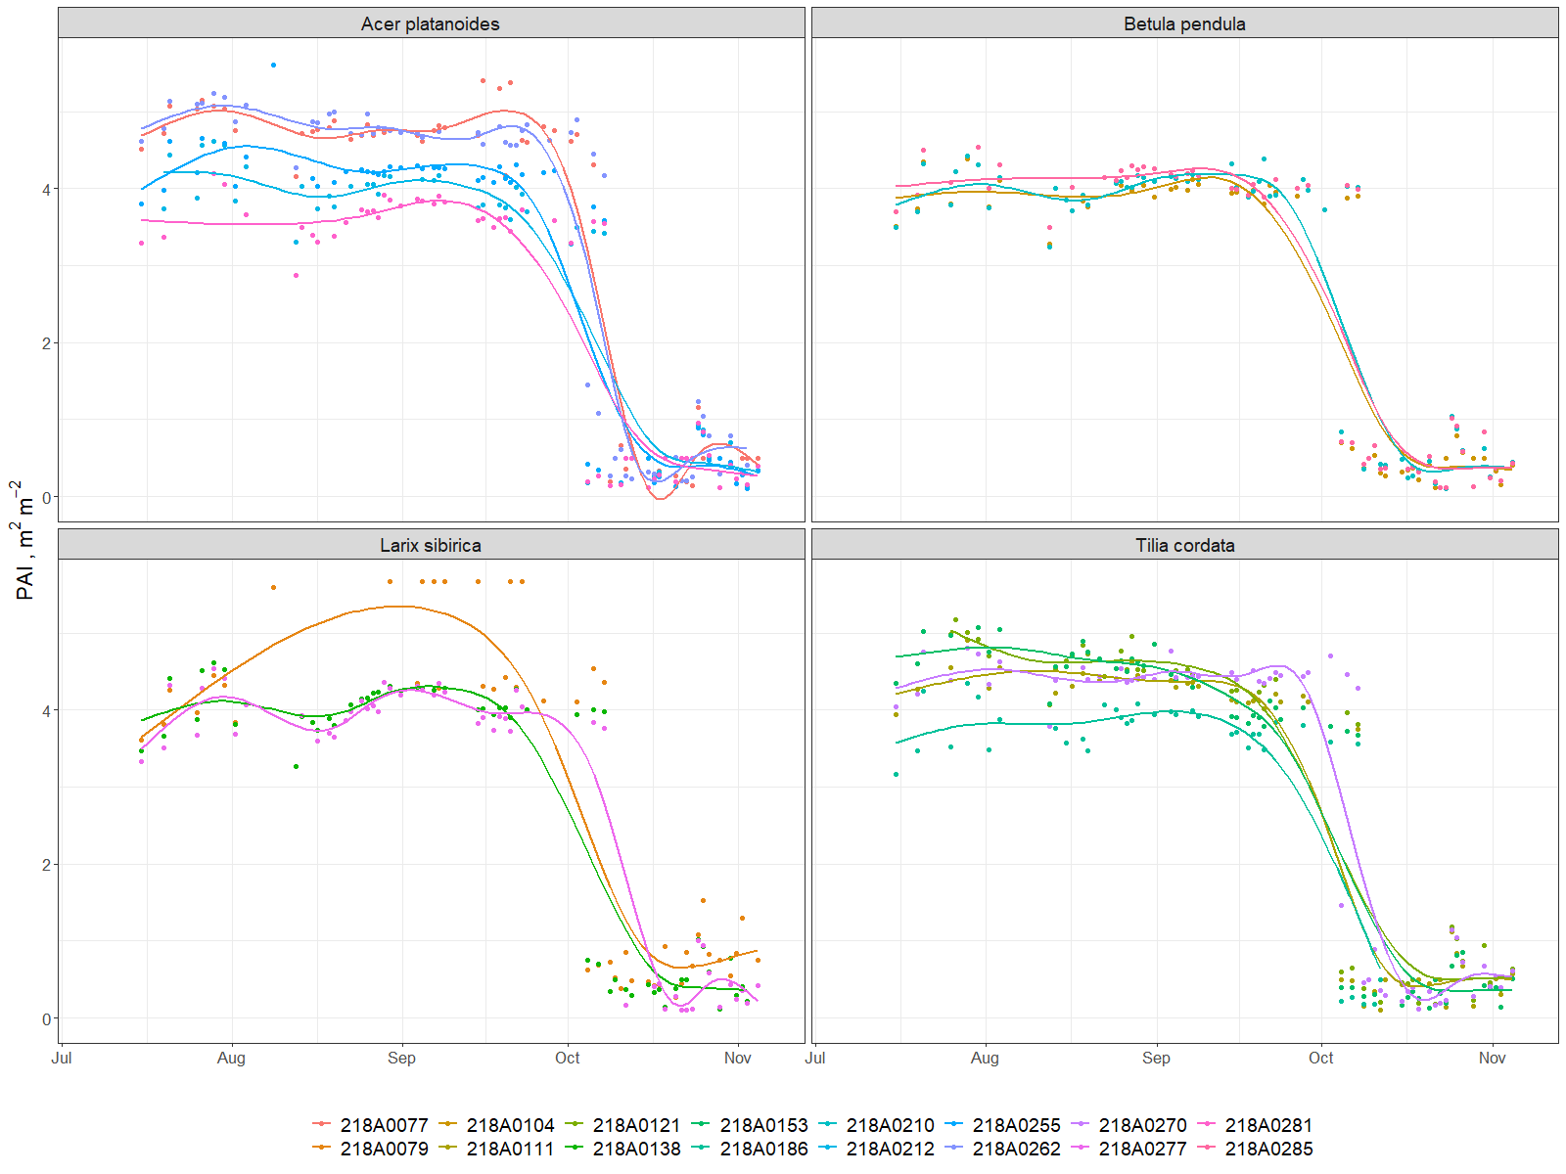

Figure 9. PAI dynamics during investigated period (July-November, 2019)

Leaf Area Index, calculated from the spectrometer was influenced by the fact that the entire canopy in the visible area of the sensor was not captured as it was situated on the one side of a tree and was affected by close position of the device to the trunk. Thus, it is necessary to compare precisely with standard technics (e.g. camera with fish-eye lens and LICOR) which are essential for calibration and validation (Bremer et al., 2017; Yan et al., 2019). But the absolute values (3-4) are comparable to most of the papers (Neinavaz et al., 2016; Taheriazad et al., 2019; Yan et al., 2019). While the strong correlation between LAI and DBH and also between LAI and tree height was shown previously for Canadian and Bavarian boreal forests (Taheriazad et al., 2019; Zhu et al., 2018) our results did not allow us to confirm this, that is possible explained with small amount of trees in consideration and urban conditions (Klingberg et al., 2017). What it also important, that we can estimate both LAI and WAI and their relation through seasonal dynamics, which is important for plant physiological processes and estimations based on it (R. Wang et al., 2019).

* 1. Particulate adsorption

Particulate adsorption is influenced by two main parameters – PAI and particulate concentration in air, according to the model described in Methods. The absorption dynamic during investigated period mostly reflected the changes in the air pollution level by particulate concentration, which shows peaks in the end of July and beginning of August, then in September and late November. While the reasons of this pollution dynamics were not in our focus, we can only say that the average absorption rates for all trees look similar and adsorption was on about 30 grams per day per tree (fig. 10).

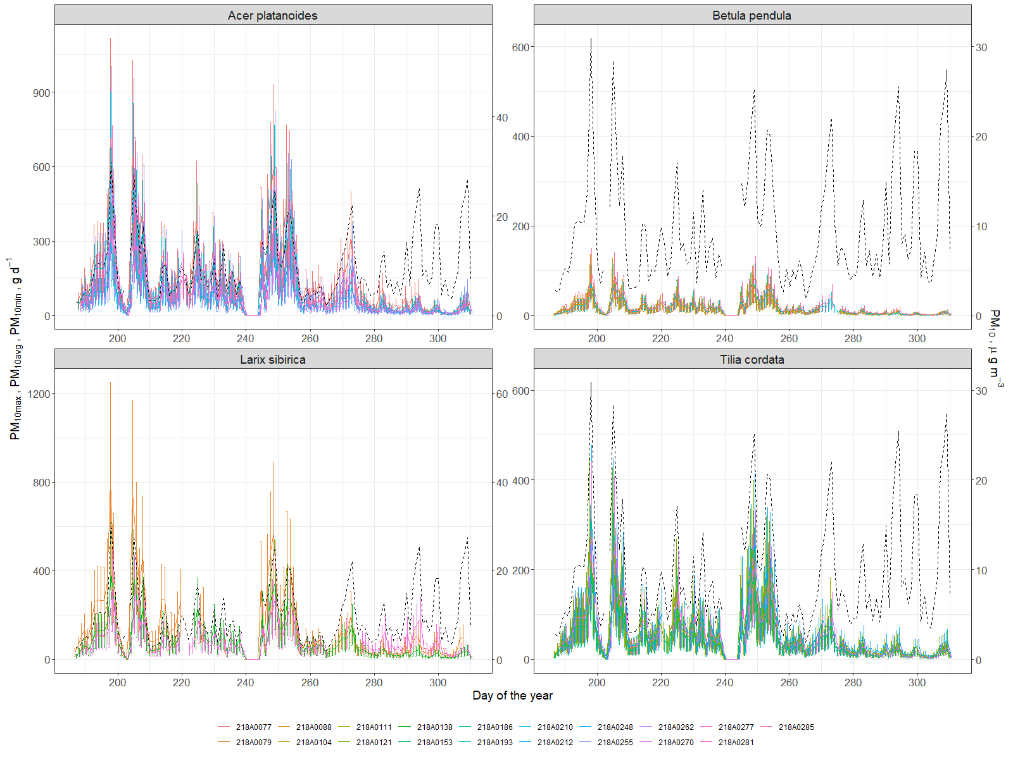

Figure 10. Dynamics of atmospheric particulate matter with diameter less than 10 micrometers(PM10) concentration in air (dashed line) and amount of PM10 absorbed by investigated trees daily

At least, resulting the whole season the average mass of particles adsorbed was around 7kg for Acer, Larix, 4kg for Tillia, and around 1,3kg for Betula (fig.11). Sæbø et al. (2012) showed that Betula improves air quality by particulate adsorption much better than Acer and Tillia, that can be explained (in our case) just by the size of a tree. It is well known that healthy large trees remove about 60 times more pollution annually than healthy small trees (Nowak et al., 2006). And leaf wax or leaf hair density and topography also influenced much (Muhammad et al., 2019; Sæbø et al., 2012), but we do not take it into account, while our calculation was based on LAI. But the total adsorption by tree seems comparable with several works with the average 1-5 g m-2 rates of adsorption in different cities (Bottalico et al., 2016; Nowak et al., 2018; Selmi et al., 2016), which resulted in 30-200g daily per tree. Thus, our results from Moscow center with very high traffic look comparable.

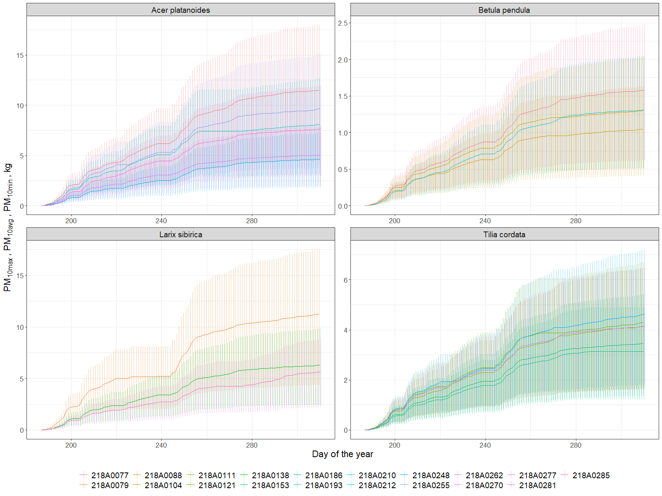

Figure 11. Cumulative particulate adsorption (minimum, average and maximum) by tree leaves per investigated period (July-November, 2019).

* 1. Main Ecosystem Services, provided by individual trees.

According to our findings the tree average was 11.7 (+- 6.8) kg of Carbon stored, 160 (+- 82) mm of water transpired, 1562.08 (+- 820.4) kWh spent for microclimate regulation and 5309.27 (+- 3235.44) g of PM10 adsorbed by average tree per investigated period (July-November, 2019). These results however show a quite large variability at individual level, thus we present a summary of data per species and different ecosystem indicators in table 4. This difference between individual ecosystem services provisioning correlates well with characteristics of a trees. Trees with higher diameter absorbed more energy via transpiration, collect more particles from the air and accumulate more carbon that is reasonable. Trunk increment influenced much by species, thus it was higher for Tillia. Transpiration ratio was higher for trees with low canopy area, which is a quite interesting finding, and higher for healthy trees (with higher VTA score) which is expectable. And position (edge or inside, alone or in group) was more important for the dynamics of the processes during investigated period neither for the total values of services.

|  |  |  |  |  |  |  |  |  |  |  |  |  |  |  |  |  |  |  |  |  |  |  |  |  |
| --- | --- | --- | --- | --- | --- | --- | --- | --- | --- | --- | --- | --- | --- | --- | --- | --- | --- | --- | --- | --- | --- | --- | --- | --- |
| **Tree descriptiom and Summative of ecosystem services produced by each tree per investigated period (July-November,2019)** | | | | | | | | | | | | | | | | | | | | | | |  |  |
|  | **Biomass carbon** | | **Transpiration and precipitation** | | | **Energy asborbed** | **PM10 particles absorbed, g** | | | **Leaf and wood indexes** | | | **Tree description** | | | | | | | | | | | |
| **id** | **Carbon stored, kg** | **Carbon stored per canopy area, kg m-2** | **Transpiration, mm** | **Precipitation, mm** | **Ratio of precipitation evaporated, mm** | **L, kWh** | **PM10max** | **PM10avg** | **PM10min** | **PAI, m2m-2** | **WAI, m2m-2** | **LAI, m2m-2** | | **Age group** | **Tree height, m** | **Trunk diameter,cm** | **Trunk growth,mm** | **Canopy area, m2** | **VTA** | **BEF** | **BCEF** | **R/S** | **Total tree carbon, kg** | **Average annual tree carbon increment, kg** |
| ***Acer platanoides*** | | | | | | | | | | | | | | | | | | | | | | | | |
| **218A0077** | 12.95 | 0.23 | 83.59 | 183.5 | 0.46 | 2454 | 17975.97 | 11504.62 | 4493.99 | 4.21 | 0.47 | 3.74 | 50-60 | | 20.02 | 35.65 | 3.36 | 55.7 | 2 | 1.31 | 1.05 | 0.317 | 580.02 | 10.55 |
| **218A0212** | 8.79 | 0.32 | 130.80 | 183.5 | 0.71 | 1615 | 7250.39 | 4640.25 | 1812.60 | 3.30 | 0.50 | 2.80 | 50-60 | | 15.17 | 33.74 | 3.18 | 27.6 | 3 | 1.31 | 1.05 | 0.317 | 393.59 | 7.16 |
| **218A0255** | 12.50 | 0.23 | 92.10 | 183.5 | 0.50 | 2506 | 15064.69 | 9641.40 | 3766.17 | 3.47 | 0.42 | 3.04 | 50-60 | | 20.78 | 34.38 | 3.24 | 55.3 | 2 | 1.31 | 1.05 | 0.317 | 559.75 | 10.18 |
| **218A0262** | 8.35 | 0.29 | 168.32 | 183.5 | 0.92 | 2739 | 7861.26 | 5031.21 | 1965.32 | 3.97 | 0.57 | 3.40 | 50-60 | | 13.62 | 34.70 | 3.27 | 28.5 | 1 | 1.31 | 1.05 | 0.317 | 373.73 | 6.80 |
| **218A0281** | 15.30 | 0.43 | 190.09 | 183.5 | 1.04 | 3042 | 11940.43 | 7641.87 | 2985.11 | 2.92 | 0.43 | 2.49 | 50-60 | | 14.30 | 45.84 | 4.32 | 35.8 | 4 | 1.31 | 1.05 | 0.317 | 684.96 | 12.45 |
| **Mean** | 11.58 | 0.30 | 132.98 | 183.50 | 0.72 | 2471.20 | 12018.55 | 7691.87 | 3004.64 | 3.57 | 0.48 | 3.10 |  | | 16.78 | 36.86 | 3.47 | 40.58 |  |  |  |  | 518.41 | 9.43 |
| **SE** | 1.47 | 0.04 | 23.22 | 0.00 | 0.13 | 266.00 | 2302.10 | 1473.34 | 575.52 | 0.26 | 0.03 | 0.25 |  | | 1.68 | 2.53 | 0.24 | 6.99 |  |  |  |  | 66.03 | 1.20 |
| ***Betula pendula*** | | | | | | | | | | | | | | | | | | | | | | | | |
| **218A0104** | 2.39 | 0.31 | 242.16 | 183.5 | 1.32 | 1157 | 2029.34 | 1298.78 | 507.33 | 3.09 | 0.44 | 2.65 | 50-60 | | 11.22 | 21.65 | 2.72 | 7.6 | 1 | 1.19 | 0.761 | 0.219 | 80.41 | 1.46 |
| **218A0210** | 2.19 | 0.34 | 304.40 | 183.5 | 1.66 | 1226 | 2046.17 | 1309.55 | 511.54 | 3.30 | 0.42 | 2.88 | 30-40 | | 10.92 | 21.01 | 2.64 | 6.4 | 1 | 1.19 | 0.761 | 0.219 | 73.70 | 1.34 |
| **218A0285** | 2.79 | 0.34 | 340.33 | 183.5 | 1.85 | 1756 | 2468.15 | 1579.61 | 617.04 | 3.24 | 0.42 | 2.82 | 30-40 | | 10.77 | 23.87 | 3 | 8.2 | 1 | 1.19 | 0.761 | 0.219 | 93.85 | 1.71 |
| **Mean** | 2.46 | 0.33 | 295.63 | 183.50 | 1.61 | 1379.39 | 2181.22 | 1395.98 | 545.30 | 3.21 | 0.43 | 2.79 |  | | 10.97 | 22.18 | 2.79 | 7.40 | 1.00 | 1.19 | 0.76 | 0.22 | 82.65 | 1.50 |
| **SE** | 0.39 | 0.10 | 100.49 | 64.88 | 0.55 | 436.73 | 149.77 | 95.86 | 37.44 | 1.05 | 0.14 | 0.90 |  | | 3.29 | 7.00 | 0.91 | 0.55 | 0.00 | 0.00 | 0.00 | 0.00 | 8.34 | 0.15 |
| ***Larix sibirica*** | | | | | | | | | | | | | | | | | | | | | | | | |
| **218A0079** | 6.28 | 0.10 | 41.04 | 183.5 | 0.22 | 1701 | 17527.53 | 11217.62 | 4381.88 | 3.49 | 0.80 | 2.69 | 80-100 | | 24.72 | 32.15 | 2.02 | 65.9 | 3 | 1.13 | 0.754 | 0.326 | 421.11 | 7.66 |
| **218A0138** | 7.75 | 0.21 | 137.62 | 183.5 | 0.75 | 3238 | 9824.85 | 6287.91 | 2456.21 | 3.38 | 0.46 | 2.92 | 80-100 | | 18.99 | 40.74 | 2.56 | 37.4 | 2 | 1.13 | 0.754 | 0.326 | 519.51 | 9.45 |
| **218A0277** | 4.06 | 0.13 | 72.88 | 183.5 | 0.40 | 1481 | 8805.20 | 5635.33 | 2201.30 | 3.72 | 0.37 | 3.35 | 80-100 | | 24.27 | 26.10 | 1.64 | 32.3 | 2 | 1.13 | 0.754 | 0.326 | 272.47 | 4.95 |
| **Mean** | 6.03 | 0.14 | 83.85 | 183.50 | 0.46 | 2140.01 | 12052.53 | 7713.62 | 3013.13 | 3.53 | 0.54 | 2.99 |  | | 22.66 | 33.00 | 2.07 | 45.20 |  |  |  |  | 404.36 | 7.35 |
| **SE** | 1.31 | 0.04 | 34.80 | 0.00 | 0.19 | 676.85 | 3372.06 | 2158.12 | 843.02 | 0.12 | 0.16 | 0.24 |  | | 2.25 | 5.20 | 0.33 | 12.80 |  |  |  |  | 87.94 | 1.60 |
| ***Tilia cordata*** | | | | | | | | | | | | | | | | | | | | | | | | |
| **218A0111** | 6.12 | 0.31 | 174.45 | 183.5 | 0.95 | 2195 | 6453.93 | 4130.52 | 1613.48 | 3.45 | 0.53 | 2.92 | 50-60 | | 12.16 | 28.01 | 5.28 | 20 | 3 | 1.16 | 0.682 | 0.282 | 137.55 | 2.50 |
| **218A0121** | 15.34 | 0.49 | 171.14 | 183.5 | 0.93 | 3370 | 6708.02 | 4293.13 | 1677.01 | 3.77 | 0.56 | 3.21 | 50-60 | | 16.68 | 37.88 | 7.14 | 31.3 | 1 | 1.16 | 0.682 | 0.282 | 345.00 | 6.27 |
| **218A0153** | 10.92 | 0.52 | 165.41 | 183.5 | 0.90 | 2196 | 5405.19 | 3459.32 | 1351.30 | 3.66 | 0.42 | 3.24 | 40-50 | | 13.65 | 35.33 | 6.66 | 21.1 | 2 | 1.16 | 0.682 | 0.282 | 245.59 | 4.47 |
| **218A0186** | 17.79 | 0.91 | 175.42 | 183.5 | 0.96 | 2152 | 4892.92 | 3131.47 | 1223.23 | 3.32 | 0.52 | 2.80 | 40-50 | | 16.99 | 40.43 | 7.62 | 19.5 | 3 | 1.16 | 0.682 | 0.282 | 400.09 | 7.27 |
| **218A0270** | 4.30 | 0.19 | 84.88 | 183.5 | 0.46 | 1196 | 6477.74 | 4145.75 | 1619.44 | 3.69 | 0.48 | 3.21 | 30-40 | | 11.00 | 25.15 | 4.74 | 22.4 | 3 | 1.16 | 0.664 | 0.272 | 96.81 | 1.76 |
| **Mean** | 10.89 | 0.48 | 154.26 | 183.50 | 0.84 | 2221.68 | 5987.56 | 3832.04 | 1496.89 | 3.58 | 0.50 | 3.08 |  | | 14.10 | 33.36 | 6.29 | 22.86 |  |  |  |  | 245.01 | 4.45 |
| **SE** | 2.89 | 0.14 | 19.49 | 0.00 | 0.11 | 385.38 | 396.41 | 253.70 | 99.10 | 0.09 | 0.03 | 0.10 |  | | 1.34 | 3.26 | 0.61 | 2.42 |  |  |  |  | 64.98 | 1.18 |

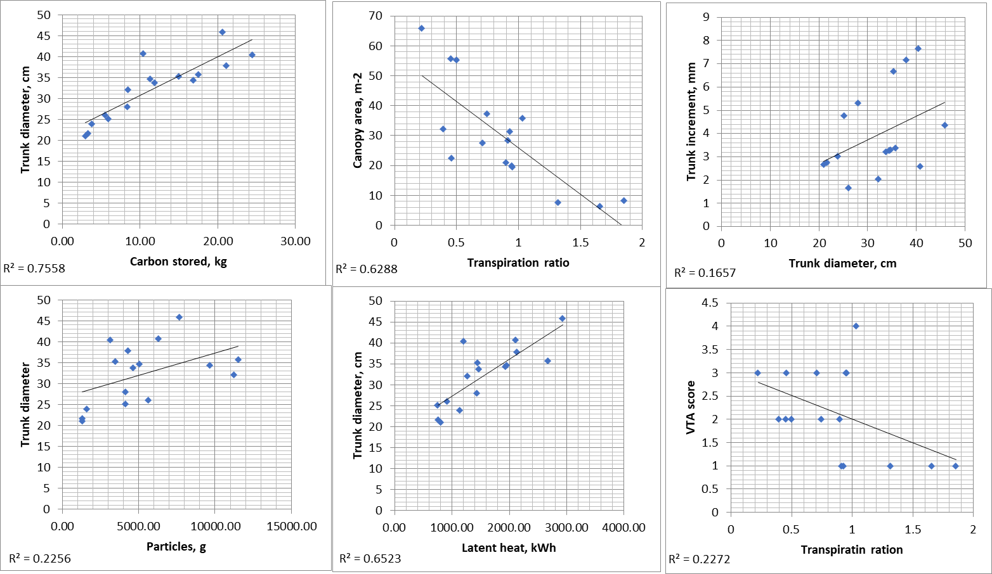

Table 4. Summative of ecosystem services produced by each tree along with their characteristics per investigated period (July-November, 2019)

|  |  |  |  |  |  |  |  |  |  |  |  |  |  |  |  |  |
| --- | --- | --- | --- | --- | --- | --- | --- | --- | --- | --- | --- | --- | --- | --- | --- | --- |
| **# TT +** | **Carbon stored, kg** | **Transpiration, mm** | **Ratio of precipitation evaporated, mm** | **Energy absorbed, kWh** | **PM10 particles absorbed, g** | | | **Tree characteristics** | | | | | | | | |
| **PM10max** | **PM10avg** | **PM10min** | **PAI, m2m-2** | **WAI, m2m-2** | **LAI, m2m-2** | **Age** | **Tree height, m** | **Trunk diameter,cm** | **Trunk increment, mm** | **Canopy area, m2** | **VTA** |
| Acer platanoides | | | | | | | | | | | | | | | | |
| 218A0077 | 9.2 | 83.6 | 0.5 | 2454 | 17976.0 | 11504.6 | 4494.0 | 4.2 | 0.5 | 3.7 | VI | 20.0 | 35.7 | 3.4 | 55.7 | 2 |
| 218A0212 | 45.5 | 130.8 | 0.7 | 1615 | 7250.4 | 4640.3 | 1812.6 | 3.3 | 0.5 | 2.8 | VI | 15.2 | 33.7 | 3.2 | 27.6 | 3 |
| 218A0255 | 9.83 | 92.1 | 0.5 | 2506 | 15064.7 | 9641.4 | 3766.2 | 3.5 | 0.4 | 3.0 | VI | 20.8 | 34.4 | 3.2 | 55.3 | 2 |
| 218A0262 | 6.88 | 168.3 | 0.9 | 2739 | 7861.3 | 5031.2 | 1965.3 | 4.0 | 0.6 | 3.4 | VI | 13.6 | 34.7 | 3.3 | 28.5 | 1 |
| 218A0281 | 28.2 | 190.1 | 1.0 | 3042 | 11940.4 | 7641.9 | 2985.1 | 2.9 | 0.4 | 2.5 | VI | 14.3 | 45.8 | 4.3 | 35.8 | 4 |
| Betula pendula | | | | | | | | | | | | | | | | |
| 218A0104 | 7.32 | 242.2 | 1.3 | 1157 | 2029.3 | 1298.8 | 507.3 | 3.1 | 0.4 | 2.7 | IV | 11.2 | 21.6 | 2.7 | 7.6 | 1 |
| 218A0210 | 11.5 | 304.4 | 1.7 | 1225 | 2046.2 | 1309.5 | 511.5 | 3.3 | 0.4 | 2.9 | IV | 10.9 | 21.0 | 2.6 | 6.4 | 1 |
| 218A0285 | 2.66 | 340.3 | 1.9 | 1755 | 2468.1 | 1579.6 | 617.0 | 3.2 | 0.4 | 2.8 | IV | 10.8 | 23.9 | 3.0 | 8.2 | 1 |
| Larix sibirica | | | | | | | | | | | | | | | | |
| 218A0079 | 11.3 | 41.0 | 0.2 | 1701. | 17527.5 | 11217.6 | 4381.9 | 3.5 | 0.8 | 2.7 | V | 24.7 | 32.1 | 2.0 | 65.9 | 3 |
| 218A0138 | 11.7 | 137.6 | 0.7 | 3237 | 9824.9 | 6287.9 | 2456.2 | 3.4 | 0.5 | 2.9 | VI | 19.0 | 40.7 | 2.6 | 37.4 | 2 |
| 218A0277 | 10 | 72.9 | 0.4 | 1480 | 8805.2 | 5635.3 | 2201.3 | 3.7 | 0.4 | 3.4 | IV | 24.3 | 26.1 | 1.6 | 32.3 | 2 |
| Tilia cordata | | | | | | | | | | | | | | | | |
| 218A0111 | 6.01 | 174.4 | 1.0 | 2194 | 6453.9 | 4130.5 | 1613.5 | 3.5 | 0.5 | 2.9 | IV | 12.2 | 28.0 | 5.3 | 20.0 | 3 |
| 218A0121 | 3.63 | 171.1 | 0.9 | 3369 | 6708.0 | 4293.1 | 1677.0 | 3.8 | 0.6 | 3.2 | VI | 16.7 | 37.9 | 7.1 | 31.3 | 1 |
| 218A0153 | 4.61 | 165.4 | 0.9 | 2195 | 5405.2 | 3459.3 | 1351.3 | 3.7 | 0.4 | 3.2 | IV | 13.6 | 35.3 | 6.7 | 21.1 | 2 |
| 218A0186 | 3.49 | 175.4 | 1.0 | 2151 | 4892.9 | 3131.5 | 1223.2 | 3.3 | 0.5 | 2.8 | VI | 17.0 | 40.4 | 7.6 | 19.5 | 3 |
| 218A0270 | 2.63 | 84.9 | 0.5 | 1196 | 6477.7 | 4145.8 | 1619.4 | 3.7 | 0.5 | 3.2 | III | 11.0 | 25.1 | 4.7 | 22.4 | 3 |

**Conclusions**

There are several approaches to provide ecosystem services information for the green infrastructure in urban areas. However, most of the inventory types approaches, even when based on high resolution imaging, are limited by the temporal resolution which sometime is important for detecting an early onset of ES decline. Our results show that an IoT tree level network, using individual tree physiology sensing devices, such as TreeTalker, or other similar devices, can be used in principle for monitoring urban green infrastructure ecosystem services in real time. Furthermore, for some of the ES indicator, such as water and cooling effects, they are most often based on models with indirect derived parameters. There are several advantages for increasing the granularity of ES monitoring, since individual trees can be managed with a greater accuracy. The cost of monitoring is therefore critical for IoT expansion in green infrastructure monitoring. In recent years technological development and low cost microprocessors, traditionally used in automation and industry processes (Industry4.0), are creating new opportunities for their expansion in environmental monitoring, that we could define as a Nature4.0 transformation (Valentini et al., 2019). An average cost of 200-300 Euro per point of measurements (tree), including the LoRa gateway, have been estimated in our experiment.

However, there are limitations and improvements to be considered in future work. First of all the power consumption of the TreeTalker devices, used in the current work, is still a big limitation. Batteries need to be replaced every 1-1.5 months which require still quite investment of labor work. New batteries are being developed with much larger capacity that in principle could extend the battery life duration. In terms of improvement a new IR sensor for remote sensing of canopy temperature could be very useful for improving the energy balance estimation and cooling effects. In particular, the installation of an anemometer will provide additional data on wind speed in the canopy, which influence much several ecosystem services. In addition simple PM2.5-10 optical devices can be included in the processor platform to get useful data on air quality using trees as monitor stations. In principle, but further studies need to be conducted, a noise sensor and microphone could also be included with the aim to provide useful information on the noise pollution and “soundscape” quality generated by trees in parks (Doser et al., 2020; Mydlarz et al., 2019) and also to evaluate associated biodiversity with the help of recorded bird songs (Farina et al., 2014; Margaritis et al., 2018). Nevertheless, the technical development of sensors along with people engagement to citizen science will be inevitable (Bauer et al., 2019; Nitoslawski et al., 2019; Schröter et al., 2017), thus it will be important to adapt them to the task of monitoring those parameters that are important for urban planning decisions (Cortinovis and Geneletti, 2019).

Among the indicators presented in the article, perhaps not all of them can be used for practical purposes directly. Air temperature and humidity under the canopy of city trees can be presented “as is” for people, as well as wind speed for example. However, in order to monitor the quality of the urban environment associated with green infrastructure, it is probably worth developing special scales of air quality, microclimate comfort and noise pollution levels – in this form it makes more clear information for citizens. On the other hand, for spatial planning tasks, annual or seasonal indicators of ecosystem services provided by one or another tree species at its specific age, height and condition will be more useful in the form of empirical data tables and spatial models, as it will affect which and where to plant trees (Bodnaruk et al., 2017). In addition, it is also necessary to take into account disservices associated with urban trees such as the fall of weakened and diseased trees on cars, infrastructure and buildings, and the allergic reaction of people to tree pollen (Speak et al., 2018; Teixeira et al., 2019). These parameters should also be continuously monitored and reported in real time for rapid response or timely prevention.

**Author Contributions:** Conceptualization, R.V. and V.M.; methodology, X.X.; software, A.Y. and L.B.; validation, X.X., Y.Y. and Z.Z.; formal analysis, X.X.; investigation, X.X.; resources, X.X., Y.Y. and Z.Z.; data curation, A.Y.; writing—original draft preparation, V.M.; writing—review and editing, R.V. and S.C.; visualization, A.Y.; supervision, R.V.; project administration, V.V.; funding acquisition, Y.Y. All authors have read and agreed to the published version of the manuscript.

**Funding:** Monitoring and modeling ecosystem services of urban trees was supported by Russian Scientific Foundation Project # 19-77-300-12. Data processing and analysis was supported by “RUDN University program 5‐100.”

**Acknowledgments:** In this section you can acknowledge any support given which is not covered by the author contribution or funding sections. This may include administrative and technical support, or donations in kind (e.g., materials used for experiments).

**Conflicts of Interest:** The authors declare no conflict of interest.

**7. Literature**

Aalders, I., Stanik, N., 2019. Spatial units and scales for cultural ecosystem services: a comparison illustrated by cultural heritage and entertainment services in Scotland. Landsc. Ecol. 34, 1635–1651. https://doi.org/10.1007/s10980-019-00827-6

Albino, V., Berardi, U., Dangelico, R.M., 2015. Smart Cities: Definitions, Dimensions, Performance, and Initiatives. J. Urban Technol. 22, 3–21. https://doi.org/10.1080/10630732.2014.942092

Alonzo, M., Bookhagen, B., Roberts, D.A., 2014. Urban tree species mapping using hyperspectral and lidar data fusion. Remote Sens. Environ. 148, 70–83. https://doi.org/10.1016/j.rse.2014.03.018

Andersson, E., Barthel, S., Borgström, S., Colding, J., Elmqvist, T., Folke, C., Gren, Å., 2014. Reconnecting Cities to the Biosphere: Stewardship of Green Infrastructure and Urban Ecosystem Services. AMBIO 43, 445–453. https://doi.org/10.1007/s13280-014-0506-y

Andersson-Sköld, Y., Klingberg, J., Gunnarsson, B., Cullinane, K., Gustafsson, I., Hedblom, M., Knez, I., Lindberg, F., Ode Sang, Å., Pleijel, H., Thorsson, P., Thorsson, S., 2018. A framework for assessing urban greenery’s effects and valuing its ecosystem services. J. Environ. Manage. 205, 274–285. https://doi.org/10.1016/j.jenvman.2017.09.071

Andrea, F., Bini, C., Amaducci, S., 2018. Soil and ecosystem services: Current knowledge and evidences from Italian case studies. Appl. Soil Ecol. 123, 693–698. https://doi.org/10.1016/j.apsoil.2017.06.031

Augustaitis, A., Augustaitienė, I., Baugarten, M., Bičenkienė, S., Girgždienė, R., Kulbokas, G., Linkevičius, E., Marozas, V., Mikalajūnas, M., Mordas, G., Mozgeris, G., Petrauskas, E., Pivoras, A., Šidlauskas, G., Ulevičius, V., Vitas, A., Matyssek, R., 2018. Tree-ring formation as an indicator of forest capacity to adapt to the main threats of environmental changes in Lithuania. Sci. Total Environ. 615, 1247–1261. https://doi.org/10.1016/j.scitotenv.2017.09.169

Augustaitis, A., Augustaitiene, I., Mozgeris, G., Juknys, R., Vitas, A., Jasinevičiene, D., 2015. Growth patterns of Scots pine (Pinus sylvestris L.) under the current regional pollution load in Lithuania. IForest - Biogeosciences For. 8, 509–516. https://doi.org/10.3832/ifor1267-007

Bauer, J., Jarmer, T., Schittenhelm, S., Siegmann, B., Aschenbruck, N., 2019. Processing and filtering of leaf area index time series assessed by in-situ wireless sensor networks. Comput. Electron. Agric. 165, 104867. https://doi.org/10.1016/j.compag.2019.104867

Bettencourt, L.M.A., Lobo, J., Helbing, D., Kuhnert, C., West, G.B., 2007. Growth, innovation, scaling, and the pace of life in cities. Proc. Natl. Acad. Sci. 104, 7301–7306. https://doi.org/10.1073/pnas.0610172104

Blanusa, T., Garratt, M., Cathcart-James, M., Hunt, L., Cameron, R.W.F., 2019. Urban hedges: A review of plant species and cultivars for ecosystem service delivery in north-west Europe. Urban For. Urban Green. 44, 126391. https://doi.org/10.1016/j.ufug.2019.126391

Bodnaruk, E.W., Kroll, C.N., Yang, Y., Hirabayashi, S., Nowak, D.J., Endreny, T.A., 2017. Where to plant urban trees? A spatially explicit methodology to explore ecosystem service tradeoffs. Landsc. Urban Plan. 157, 457–467. https://doi.org/10.1016/j.landurbplan.2016.08.016

Bolund, P., Hunhammar, S., 1999. Ecosystem services in urban areas. Ecol. Econ. 29, 293–301. https://doi.org/10.1016/S0921-8009(99)00013-0

Bottalico, F., Chirici, G., Giannetti, F., De Marco, A., Nocentini, S., Paoletti, E., Salbitano, F., Sanesi, G., Serenelli, C., Travaglini, D., 2016. Air Pollution Removal by Green Infrastructures and Urban Forests in the City of Florence. Agric. Agric. Sci. Procedia 8, 243–251. https://doi.org/10.1016/j.aaspro.2016.02.099

Bremer, M., Wichmann, V., Rutzinger, M., 2017. Calibration and Validation of a Detailed Architectural Canopy Model Reconstruction for the Simulation of Synthetic Hemispherical Images and Airborne LiDAR Data. Remote Sens. 9, 220. https://doi.org/10.3390/rs9030220

Buccolieri, R., Santiago, J.-L., Rivas, E., Sáanchez, B., 2019. Reprint of: Review on urban tree modelling in CFD simulations: Aerodynamic, deposition and thermal effects. Urban For. Urban Green. 37, 56–64. https://doi.org/10.1016/j.ufug.2018.07.004

Burkhard, B., Maes, J., Potschin-Young, M., Santos-Martín, F., Geneletti, D., Stoev, P., Kopperoinen, L., Adamescu, C., Adem Esmail, B., Arany, I., Arnell, A., Balzan, M., Barton, D.N., van Beukering, P., Bicking, S., Borges, P., Borisova, B., Braat, L., M Brander, L., Bratanova-Doncheva, S., Broekx, S., Brown, C., Cazacu, C., Crossman, N., Czúcz, B., Daněk, J., Groot, R. de, Depellegrin, D., Dimopoulos, P., Elvinger, N., Erhard, M., Fagerholm, N., Frélichová, J., Grêt-Regamey, A., Grudova, M., Haines-Young, R., Inghe, O., Kallay, T., Kirin, T., Klug, H., Kokkoris, I., Konovska, I., Kruse, M., Kuzmova, I., Lange, M., Liekens, I., Lotan, A., Lowicki, D., Luque, S., Marta-Pedroso, C., Mizgajski, A., Mononen, L., Mulder, S., Müller, F., Nedkov, S., Nikolova, M., Östergård, H., Penev, L., Pereira, P., Pitkänen, K., Plieninger, T., Rabe, S.-E., Reichel, S., Roche, P., Rusch, G., Ruskule, A., Sapundzhieva, A., Sepp, K., Sieber, I., Šmid Hribar, M., Stašová, S., Steinhoff-Knopp, B., Stępniewska, M., Teller, A., Vackar, D., van Weelden, M., Veidemane, K., Vejre, H., Vihervaara, P., Viinikka, A., Villoslada, M., Weibel, B., Zulian, G., 2018. Mapping and assessing ecosystem services in the EU - Lessons learned from the ESMERALDA approach of integration. One Ecosyst. 3. https://doi.org/10.3897/oneeco.3.e29153

Chen, X., Zhao, P., Hu, Y., Ouyang, L., Zhu, L., Ni, G., 2019. Canopy transpiration and its cooling effect of three urban tree species in a subtropical city- Guangzhou, China. Urban For. Urban Green. 43, 126368. https://doi.org/10.1016/j.ufug.2019.126368

Cortinovis, C., Geneletti, D., 2019. A framework to explore the effects of urban planning decisions on regulating ecosystem services in cities. Ecosyst. Serv. 38, 100946. https://doi.org/10.1016/j.ecoser.2019.100946

Czúcz, B., Arany, I., Potschin-Young, M., Bereczki, K., Kertész, M., Kiss, M., Aszalós, R., Haines-Young, R., 2018. Where concepts meet the real world: A systematic review of ecosystem service indicators and their classification using CICES. Ecosyst. Serv. 29, 145–157. https://doi.org/10.1016/j.ecoser.2017.11.018

Do, F.C., Puangjumpa, N., Rocheteau, A., Duthoit, M., Nhean, S., Isarangkool Na Ayutthaya, S., 2018. Towards reduced heating duration in the transient thermal dissipation system of sap flow measurements. Acta Hortic. 149–154. https://doi.org/10.17660/ActaHortic.2018.1222.31

Doser, J.W., Finley, A.O., Kasten, E.P., Gage, S.H., 2020. Assessing soundscape disturbance through hierarchical models and acoustic indices: A case study on a shelterwood logged northern Michigan forest. Ecol. Indic. 113, 106244. https://doi.org/10.1016/j.ecolind.2020.106244

Drobnik, T., Greiner, L., Keller, A., Grêt-Regamey, A., 2018. Soil quality indicators – From soil functions to ecosystem services. Ecol. Indic. 94, 151–169. https://doi.org/10.1016/j.ecolind.2018.06.052

Dye, C., 2008. Health and Urban Living. Science 319, 766. https://doi.org/10.1126/science.1150198

Elliott, S., 2016. The potential for automating assisted natural regeneration of tropical forest ecosystems. Biotropica 48, 825–833. https://doi.org/10.1111/btp.12387

Farina, A., James, P., Bobryk, C., Pieretti, N., Lattanzi, E., McWilliam, J., 2014. Low cost (audio) recording (LCR) for advancing soundscape ecology towards the conservation of sonic complexity and biodiversity in natural and urban landscapes. Urban Ecosyst. 17, 923–944. https://doi.org/10.1007/s11252-014-0365-0

Frumkin, H., 2003. Healthy Places: Exploring the Evidence. Am. J. Public Health 93, 1451–1456. https://doi.org/10.2105/AJPH.93.9.1451

Gómez-Baggethun, E., Barton, D.N., 2013. Classifying and valuing ecosystem services for urban planning. Ecol. Econ. 86, 235–245. https://doi.org/10.1016/j.ecolecon.2012.08.019

Granier A D1985] Une nouvelle methode pour la mesure du flux de seve brute dans le tronc des arbres. Ann Sci For 42:81–88, In French

Gratani, L., Varone, L., 2006. Carbon sequestration by Quercus ilex L. and Quercus pubescens Willd. and their contribution to decreasing air temperature in Rome. Urban Ecosyst. 9, 27–37. https://doi.org/10.1007/s11252-006-5527-2

Grimm, N.B., Faeth, S.H., Golubiewski, N.E., Redman, C.L., Wu, J., Bai, X., Briggs, J.M., 2008. Global Change and the Ecology of Cities. Science 319, 756. https://doi.org/10.1126/science.1150195

Guo, Z., Zhang, L., Li, Y., 2010. Increased Dependence of Humans on Ecosystem Services and Biodiversity. PLoS ONE 5, e13113. https://doi.org/10.1371/journal.pone.0013113

Haaren, C. von, Lovett, A.A., Albert, C., 2019. Landscape planning with ecosystem services: theories and methods for application in Europe.

Haase, D., Larondelle, N., Andersson, E., Artmann, M., Borgström, S., Breuste, J., Gomez-Baggethun, E., Gren, Å., Hamstead, Z., Hansen, R., Kabisch, N., Kremer, P., Langemeyer, J., Rall, E.L., McPhearson, T., Pauleit, S., Qureshi, S., Schwarz, N., Voigt, A., Wurster, D., Elmqvist, T., 2014. A Quantitative Review of Urban Ecosystem Service Assessments: Concepts, Models, and Implementation. AMBIO 43, 413–433. https://doi.org/10.1007/s13280-014-0504-0

Hefny Salim, M., Heinke Schlünzen, K., Grawe, D., 2015. Including trees in the numerical simulations of the wind flow in urban areas: Should we care? J. Wind Eng. Ind. Aerodyn. 144, 84–95. https://doi.org/10.1016/j.jweia.2015.05.004

Hirabayashi, S., Kroll, C.N., Nowak, D.J., 2012. i-Tree Eco Dry Deposition Model Descriptions 36.

Kang, G., Kim, J.-J., Choi, W., 2020. Computational fluid dynamics simulation of tree effects on pedestrian wind comfort in an urban area. Sustain. Cities Soc. 56, 102086. https://doi.org/10.1016/j.scs.2020.102086

Kitchin, R., 2014. The real-time city? Big data and smart urbanism. GeoJournal 79, 1–14. https://doi.org/10.1007/s10708-013-9516-8

Klingberg, J., Konarska, J., Lindberg, F., Johansson, L., Thorsson, S., 2017. Mapping leaf area of urban greenery using aerial LiDAR and ground-based measurements in Gothenburg, Sweden. Urban For. Urban Green. 26, 31–40. https://doi.org/10.1016/j.ufug.2017.05.011

Krausmann, F., Lauk, C., Haas, W., Wiedenhofer, D., 2018. From resource extraction to outflows of wastes and emissions: The socioeconomic metabolism of the global economy, 1900–2015. Glob. Environ. Change 52, 131–140. https://doi.org/10.1016/j.gloenvcha.2018.07.003

Krayenhoff, E.S., Jiang, T., Christen, A., Martilli, A., Oke, T.R., Bailey, B.N., Nazarian, N., Voogt, J.A., Giometto, M.G., Stastny, A., Crawford, B.R., 2020. A multi-layer urban canopy meteorological model with trees (BEP-Tree): Street tree impacts on pedestrian-level climate. Urban Clim. 32, 100590. https://doi.org/10.1016/j.uclim.2020.100590

Kremer, P., Hamstead, Z.A., McPhearson, T., 2016. The value of urban ecosystem services in New York City: A spatially explicit multicriteria analysis of landscape scale valuation scenarios. Environ. Sci. Policy 62, 57–68. https://doi.org/10.1016/j.envsci.2016.04.012

La Rosa, D., Spyra, M., Inostroza, L., 2016. Indicators of Cultural Ecosystem Services for urban planning: A review. Ecol. Indic. 61, 74–89. https://doi.org/10.1016/j.ecolind.2015.04.028

LeBlanc DC (1992) Spatial and temporal variation in the prevalence of growth decline in red spruce populations of the northeastern United States. Canadian Journal of Forest Research,22, 1351–1363.

Lederbogen, F., Kirsch, P., Haddad, L., Streit, F., Tost, H., Schuch, P., Wüst, S., Pruessner, J.C., Rietschel, M., Deuschle, M., Meyer-Lindenberg, A., 2011. City living and urban upbringing affect neural social stress processing in humans. Nature 474, 498–501. https://doi.org/10.1038/nature10190

Lee, K.H., Ehsani, R., Castle, W.S., 2010. A laser scanning system for estimating wind velocity reduction through tree windbreaks. Comput. Electron. Agric. 73, 1–6. https://doi.org/10.1016/j.compag.2010.03.007

Lilly, P.J., Jenkins, J.C., Carroll, M.J., 2015. Management alters C allocation in turfgrass lawns. Landsc. Urban Plan. 134, 119–126. https://doi.org/10.1016/j.landurbplan.2014.10.011

Lin, J., Kroll, C.N., Nowak, D.J., Greenfield, E.J., 2019. A review of urban forest modeling: Implications for management and future research. Urban For. Urban Green. 43, 126366. https://doi.org/10.1016/j.ufug.2019.126366

Lindén, L., Riikonen, A., Setälä, H., Yli-Pelkonen, V., 2020. Quantifying carbon stocks in urban parks under cold climate conditions. Urban For. Urban Green. 49, 126633. https://doi.org/10.1016/j.ufug.2020.126633

Livesley, S.J., McPherson, E.G., Calfapietra, C., 2016. The Urban Forest and Ecosystem Services: Impacts on Urban Water, Heat, and Pollution Cycles at the Tree, Street, and City Scale. J. Environ. Qual. 45, 119–124. https://doi.org/10.2134/jeq2015.11.0567

Lovell, S.T., Taylor, J.R., 2013. Supplying urban ecosystem services through multifunctional green infrastructure in the United States. Landsc. Ecol. 28, 1447–1463. https://doi.org/10.1007/s10980-013-9912-y

Luederitz, C., Brink, E., Gralla, F., Hermelingmeier, V., Meyer, M., Niven, L., Panzer, L., Partelow, S., Rau, A.-L., Sasaki, R., Abson, D.J., Lang, D.J., Wamsler, C., von Wehrden, H., 2015. A review of urban ecosystem services: six key challenges for future research. Ecosyst. Serv. 14, 98–112. https://doi.org/10.1016/j.ecoser.2015.05.001

Marando, F., Salvatori, E., Sebastiani, A., Fusaro, L., Manes, F., 2019. Regulating Ecosystem Services and Green Infrastructure: assessment of Urban Heat Island effect mitigation in the municipality of Rome, Italy. Ecol. Model. 392, 92–102. https://doi.org/10.1016/j.ecolmodel.2018.11.011

Marchionni, V., Guyot, A., Tapper, N., Walker, J.P., Daly, E., 2019. Water balance and tree water use dynamics in remnant urban reserves. J. Hydrol. 575, 343–353. https://doi.org/10.1016/j.jhydrol.2019.05.022

Margaritis, E., Kang, J., Filipan, K., Botteldooren, D., 2018. The influence of vegetation and surrounding traffic noise parameters on the sound environment of urban parks. Appl. Geogr. 94, 199–212. https://doi.org/10.1016/j.apgeog.2018.02.017

Martens, M.J.M., Michelsen, A., 1981. Absorption of acoustic energy by plant leaves. J. Acoust. Soc. Am. 69, 303–306. https://doi.org/10.1121/1.385313

Mascarenhas, A., Ramos, T.B., Haase, D., Santos, R., 2016. Participatory selection of ecosystem services for spatial planning: Insights from the Lisbon Metropolitan Area, Portugal. Ecosyst. Serv. 18, 87–99. https://doi.org/10.1016/j.ecoser.2016.02.011

Mesas-Carrascosa, F.J., Verdú Santano, D., Meroño, J.E., Sánchez de la Orden, M., García-Ferrer, A., 2015. Open source hardware to monitor environmental parameters in precision agriculture. Biosyst. Eng. 137, 73–83. https://doi.org/10.1016/j.biosystemseng.2015.07.005

Mexia, T., Vieira, J., Príncipe, A., Anjos, A., Silva, P., Lopes, N., Freitas, C., Santos-Reis, M., Correia, O., Branquinho, C., Pinho, P., 2018. Ecosystem services: Urban parks under a magnifying glass. Environ. Res. 160, 469–478. https://doi.org/10.1016/j.envres.2017.10.023

Moghbel, M., Erfanian Salim, R., 2017. Environmental benefits of green roofs on microclimate of Tehran with specific focus on air temperature, humidity and CO 2 content. Urban Clim. 20, 46–58. https://doi.org/10.1016/j.uclim.2017.02.012

Morakinyo, T.E., Ouyang, W., Lau, K.K.-L., Ren, C., Ng, E., 2020. Right tree, right place (urban canyon): Tree species selection approach for optimum urban heat mitigation - development and evaluation. Sci. Total Environ. 719, 137461. https://doi.org/10.1016/j.scitotenv.2020.137461

Moser, A., Rötzer, T., Pauleit, S., Pretzsch, H., 2015. Structure and ecosystem services of small-leaved lime (Tilia cordata Mill.) and black locust (Robinia pseudoacacia L.) in urban environments. Urban For. Urban Green. 14, 1110–1121. https://doi.org/10.1016/j.ufug.2015.10.005

Muhammad, S., Wuyts, K., Samson, R., 2019. Atmospheric net particle accumulation on 96 plant species with contrasting morphological and anatomical leaf characteristics in a common garden experiment. Atmos. Environ. 202, 328–344. https://doi.org/10.1016/j.atmosenv.2019.01.015

Müller, F., Burkhard, B., 2012. The indicator side of ecosystem services. Ecosyst. Serv. 1, 26–30. https://doi.org/10.1016/j.ecoser.2012.06.001

Mydlarz, C., Sharma, M., Lockerman, Y., Steers, B., Silva, C., Bello, J., 2019. The Life of a New York City Noise Sensor Network. Sensors 19, 1415. https://doi.org/10.3390/s19061415

Neinavaz, E., Skidmore, A.K., Darvishzadeh, R., Groen, T.A., 2016. Retrieval of leaf area index in different plant species using thermal hyperspectral data. ISPRS J. Photogramm. Remote Sens. 119, 390–401. https://doi.org/10.1016/j.isprsjprs.2016.07.001

Neugarten, R.A., Langhammer, P.F., Osipova, E., Bagstad, K.J., Bhagabati, N., Butchart, S.H.M., Dudley, N., Elliott, V., Gerber, L.R., Gutierrez Arrellano, C., Ivanić, K.-Z., Kettunen, M., Mandle, L., Merriman, J.C., Mulligan, M., Peh, K.S.-H., Raudsepp-Hearne, C., Semmens, D.J., Stolton, S., Willcock, S., 2018. Tools for measuring, modelling, and valuing ecosystem services: guidance for Key Biodiversity Areas, natural World Heritage sites, and protected areas, 1st ed. IUCN, International Union for Conservation of Nature. https://doi.org/10.2305/IUCN.CH.2018.PAG.28.en

Nitoslawski, S.A., Galle, N.J., Van Den Bosch, C.K., Steenberg, J.W.N., 2019. Smarter ecosystems for smarter cities? A review of trends, technologies, and turning points for smart urban forestry. Sustain. Cities Soc. 51, 101770. https://doi.org/10.1016/j.scs.2019.101770

Njue, N., Stenfert Kroese, J., Gräf, J., Jacobs, S.R., Weeser, B., Breuer, L., Rufino, M.C., 2019. Citizen science in hydrological monitoring and ecosystem services management: State of the art and future prospects. Sci. Total Environ. 693, 133531. https://doi.org/10.1016/j.scitotenv.2019.07.337

Norton, L., Greene, S., Scholefield, P., Dunbar, M., 2016. The importance of scale in the development of ecosystem service indicators? Ecol. Indic. 61, 130–140. https://doi.org/10.1016/j.ecolind.2015.08.051

Nowak, D.J., Crane, D.E., 2002. Carbon storage and sequestration by urban trees in the USA. Environ. Pollut. 116, 381–389. https://doi.org/10.1016/S0269-7491(01)00214-7

Nowak, D.J., Crane, D.E., Stevens, J.C., 2006. Air pollution removal by urban trees and shrubs in the United States. Urban For. Urban Green. 4, 115–123. https://doi.org/10.1016/j.ufug.2006.01.007

Nowak, D.J., Hirabayashi, S., Doyle, M., McGovern, M., Pasher, J., 2018. Air pollution removal by urban forests in Canada and its effect on air quality and human health. Urban For. Urban Green. 29, 40–48. https://doi.org/10.1016/j.ufug.2017.10.019

Opdam, P., Luque, S., Nassauer, J., Verburg, P.H., Wu, J., 2018. How can landscape ecology contribute to sustainability science? Landsc. Ecol. 33, 1–7. https://doi.org/10.1007/s10980-018-0610-7

Pereira, F.L., Gash, J.H.C., David, J.S., Valente, F., 2009. Evaporation of intercepted rainfall from isolated evergreen oak trees: Do the crowns behave as wet bulbs? Agric. For. Meteorol. 149, 667–679. https://doi.org/10.1016/j.agrformet.2008.10.013

Prasad Ghimire, C., Adrian Bruijnzeel, L., Lubczynski, M.W., Ravelona, M., Zwartendijk, B.W., van Meerveld, H.J. (Ilja), 2017. Measurement and modeling of rainfall interception by two differently aged secondary forests in upland eastern Madagascar. J. Hydrol. 545, 212–225. https://doi.org/10.1016/j.jhydrol.2016.10.032

Puzachenko, Y., Sandlersky, R., Sankovski, A., 2013. Methods of Evaluating Thermodynamic Properties of Landscape Cover Using Multispectral Reflected Radiation Measurements by the Landsat Satellite. Entropy 15, 3970–3982. https://doi.org/10.3390/e15093970

Puzachenko, Yu.G., Sandlersky, R.B., Krenke, A.N., Puzachenko, Yu.M., 2014. Multispectral remote information in forest research. Contemp. Probl. Ecol. 7, 838–854. https://doi.org/10.1134/S1995425514070087

R Core Team, 2014. R: A language and environment for statistical computing. R Foundation for Statistical Computing, Vienna, Austria.

Rahman, M.A., Stratopoulos, L.M.F., Moser-Reischl, A., Zölch, T., Häberle, K.-H., Rötzer, T., Pretzsch, H., Pauleit, S., 2020. Traits of trees for cooling urban heat islands: A meta-analysis. Build. Environ. 170, 106606. https://doi.org/10.1016/j.buildenv.2019.106606

Rötzer, T., Rahman, M.A., Moser-Reischl, A., Pauleit, S., Pretzsch, H., 2019. Process based simulation of tree growth and ecosystem services of urban trees under present and future climate conditions. Sci. Total Environ. 676, 651–664. https://doi.org/10.1016/j.scitotenv.2019.04.235

Sæbø, A., Popek, R., Nawrot, B., Hanslin, H.M., Gawronska, H., Gawronski, S.W., 2012. Plant species differences in particulate matter accumulation on leaf surfaces. Sci. Total Environ. 427–428, 347–354. https://doi.org/10.1016/j.scitotenv.2012.03.084

Scharenbroch, B.C., Morgenroth, J., Maule, B., 2016. Tree Species Suitability to Bioswales and Impact on the Urban Water Budget. J. Environ. Qual. 45, 199–206. https://doi.org/10.2134/jeq2015.01.0060

Schepaschenko, D., Moltchanova, E., Shvidenko, A., Blyshchyk, V., Dmitriev, E., Martynenko, O., See, L., Kraxner, F., 2018. Improved Estimates of Biomass Expansion Factors for Russian Forests. Forests 9, 312. https://doi.org/10.3390/f9060312

Schröter, M., Kraemer, R., Mantel, M., Kabisch, N., Hecker, S., Richter, A., Neumeier, V., Bonn, A., 2017. Citizen science for assessing ecosystem services: Status, challenges and opportunities. Ecosyst. Serv. 28, 80–94. https://doi.org/10.1016/j.ecoser.2017.09.017

Schwilch, G., Lemann, T., Berglund, Ö., Camarotto, C., Cerdà, A., Daliakopoulos, I., Kohnová, S., Krzeminska, D., Marañón, T., Rietra, R., Siebielec, G., Thorsson, J., Tibbett, M., Valente, S., van Delden, H., van den Akker, J., Verzandvoort, S., Vrînceanu, N., Zoumides, C., Hessel, R., 2018. Assessing Impacts of Soil Management Measures on Ecosystem Services. Sustainability 10, 4416. https://doi.org/10.3390/su10124416

Selmi, W., Weber, C., Rivière, E., Blond, N., Mehdi, L., Nowak, D., 2016. Air pollution removal by trees in public green spaces in Strasbourg city, France. Urban For. Urban Green. 17, 192–201. https://doi.org/10.1016/j.ufug.2016.04.010

Seto, K.C., Guneralp, B., Hutyra, L.R., 2012. Global forecasts of urban expansion to 2030 and direct impacts on biodiversity and carbon pools. Proc. Natl. Acad. Sci. 109, 16083–16088. https://doi.org/10.1073/pnas.1211658109

Smets, V., Wirion, C., Bauwens, W., Hermy, M., Somers, B., Verbeiren, B., 2019. The importance of city trees for reducing net rainfall: comparing measurements and simulations. Hydrol. Earth Syst. Sci. 23, 3865–3884. https://doi.org/10.5194/hess-23-3865-2019

Song, X.P., Tan, P.Y., Edwards, P., Richards, D., 2018. The economic benefits and costs of trees in urban forest stewardship: A systematic review. Urban For. Urban Green. 29, 162–170. https://doi.org/10.1016/j.ufug.2017.11.017

Speak, A., Escobedo, F.J., Russo, A., Zerbe, S., 2018. An ecosystem service-disservice ratio: Using composite indicators to assess the net benefits of urban trees. Ecol. Indic. 95, 544–553. https://doi.org/10.1016/j.ecolind.2018.07.048

Spyra, M., Kleemann, J., Cetin, N.I., Vázquez Navarrete, C.J., Albert, C., Palacios-Agundez, I., Ametzaga-Arregi, I., La Rosa, D., Rozas-Vásquez, D., Adem Esmail, B., Picchi, P., Geneletti, D., König, H.J., Koo, H., Kopperoinen, L., Fürst, C., 2019. The ecosystem services concept: a new Esperanto to facilitate participatory planning processes? Landsc. Ecol. 34, 1715–1735. https://doi.org/10.1007/s10980-018-0745-6

Syrbe, R.-U., Schorcht, M., Grunewald, K., Meinel, G., 2018. Indicators for a nationwide monitoring of ecosystem services in Germany exemplified by the mitigation of soil erosion by water. Ecol. Indic. 94, 46–54. https://doi.org/10.1016/j.ecolind.2017.05.035

Taheriazad, L., Moghadas, H., Sanchez-Azofeifa, A., 2019. Calculation of leaf area index in a Canadian boreal forest using adaptive voxelization and terrestrial LiDAR. Int. J. Appl. Earth Obs. Geoinformation 83, 101923. https://doi.org/10.1016/j.jag.2019.101923

Teixeira, F.Z., Bachi, L., Blanco, J., Zimmermann, I., Welle, I., Carvalho-Ribeiro, S.M., 2019. Perceived ecosystem services (ES) and ecosystem disservices (EDS) from trees: insights from three case studies in Brazil and France. Landsc. Ecol. 34, 1583–1600. https://doi.org/10.1007/s10980-019-00778-y

Tonyaloğlu, E.E., 2020. Spatiotemporal dynamics of urban ecosystem services in Turkey: The case of Bornova, Izmir. Urban For. Urban Green. 49, 126631. https://doi.org/10.1016/j.ufug.2020.126631

UNEP (Ed.), 2010. Mainstreaming the economics of nature: a synthesis of the approach, conclusions and recommendations of teeb, The economics of ecosystems & biodiversity. UNEP, Geneva.

Urban, J., Rubtsov, A.V., Urban, A.V., Shashkin, A.V., Benkova, V.E., 2019. Canopy transpiration of a Larix sibirica and Pinus sylvestris forest in Central Siberia. Agric. For. Meteorol. 271, 64–72. https://doi.org/10.1016/j.agrformet.2019.02.038

Valente, F., Gash, J.H., Nóbrega, C., David, J.S., Pereira, F.L., 2020. Modelling rainfall interception by an olive-grove/pasture system with a sparse tree canopy. J. Hydrol. 581, 124417. https://doi.org/10.1016/j.jhydrol.2019.124417

Valentini, R., Belelli Marchesini, L., Gianelle, D., Sala, G., Yarovslavtsev, A., Vasenev, V., Castaldi, S., 2019. New tree monitoring systems: from Industry 4.0 to Nature 4.0. Ann. Silvic. Res. 43. https://doi.org/10.12899/asr-1847

van Oudenhoven, A.P.E., Petz, K., Alkemade, R., Hein, L., de Groot, R.S., 2012. Framework for systematic indicator selection to assess effects of land management on ecosystem services. Ecol. Indic. 21, 110–122. https://doi.org/10.1016/j.ecolind.2012.01.012

van Oudenhoven, A.P.E., Schröter, M., Drakou, E.G., Geijzendorffer, I.R., Jacobs, S., van Bodegom, P.M., Chazee, L., Czúcz, B., Grunewald, K., Lillebø, A.I., Mononen, L., Nogueira, A.J.A., Pacheco-Romero, M., Perennou, C., Remme, R.P., Rova, S., Syrbe, R.-U., Tratalos, J.A., Vallejos, M., Albert, C., 2018. Key criteria for developing ecosystem service indicators to inform decision making. Ecol. Indic. 95, 417–426. https://doi.org/10.1016/j.ecolind.2018.06.020

Van Reeth, W., 2013. Ecosystem Service Indicators, in: Ecosystem Services. Elsevier, pp. 41–61. https://doi.org/10.1016/B978-0-12-419964-4.00004-4

Van Renterghem, T., 2014. Guidelines for optimizing road traffic noise shielding by non-deep tree belts. Ecol. Eng. 69, 276–286. https://doi.org/10.1016/j.ecoleng.2014.04.029

Vasenev, V.I., Yaroslavtsev, A.M., Vasenev, I.I., Demina, S.A., Dovltetyarova, E.A., 2019. Land-Use Change in New Moscow: First Outcomes after Five Years of Urbanization. Geogr. Environ. Sustain. 12, 24–34. https://doi.org/10.24057/2071-9388-2019-89

Vihervaara, P., Viinikka, A., Brander, L., Santos-Martín, F., Poikolainen, L., Nedkov, S., 2019. Methodological interlinkages for mapping ecosystem services – from data to analysis and decision-support. One Ecosyst. 4. https://doi.org/10.3897/oneeco.4.e26368

von Döhren, P., Haase, D., 2019. Risk assessment concerning urban ecosystem disservices: The example of street trees in Berlin, Germany. Ecosyst. Serv. 40, 101031. https://doi.org/10.1016/j.ecoser.2019.101031

Wang, R., Chen, J.M., Luo, X., Black, A., Arain, A., 2019. Seasonality of leaf area index and photosynthetic capacity for better estimation of carbon and water fluxes in evergreen conifer forests. Agric. For. Meteorol. 279, 107708. https://doi.org/10.1016/j.agrformet.2019.107708

Wang, X., Liu, F., Wang, C., 2019. Towards a standardized protocol for measuring leaf area index in deciduous forests with litterfall collection. For. Ecol. Manag. 447, 87–94. https://doi.org/10.1016/j.foreco.2019.05.050

Wilkinson, C., Saarne, T., Peterson, G.D., Colding, J., 2013. Strategic Spatial Planning and the Ecosystem Services Concept - an Historical Exploration. Ecol. Soc. 18, art37. https://doi.org/10.5751/ES-05368-180137

Willcock, S., Hooftman, D., Sitas, N., O’Farrell, P., Hudson, M.D., Reyers, B., Eigenbrod, F., Bullock, J.M., 2016. Do ecosystem service maps and models meet stakeholders’ needs? A preliminary survey across sub-Saharan Africa. Ecosyst. Serv. 18, 110–117. https://doi.org/10.1016/j.ecoser.2016.02.038

Wissen Hayek, U., Teich, M., Klein, T.M., Grêt-Regamey, A., 2016. Bringing ecosystem services indicators into spatial planning practice: Lessons from collaborative development of a web-based visualization platform. Ecol. Indic. 61, 90–99. https://doi.org/10.1016/j.ecolind.2015.03.035

Wu, J., 2013. Landscape sustainability science: ecosystem services and human well-being in changing landscapes. Landsc. Ecol. 28, 999–1023. https://doi.org/10.1007/s10980-013-9894-9

Xiao, Q., McPherson, E.G., 2016. Surface Water Storage Capacity of Twenty Tree Species in Davis, California. J. Environ. Qual. 45, 188–198. https://doi.org/10.2134/jeq2015.02.0092

Yan, G., Hu, R., Luo, J., Weiss, M., Jiang, H., Mu, X., Xie, D., Zhang, W., 2019. Review of indirect optical measurements of leaf area index: Recent advances, challenges, and perspectives. Agric. For. Meteorol. 265, 390–411. https://doi.org/10.1016/j.agrformet.2018.11.033

Yang, H.-S., Kang, J., Cheal, C., Renterghem, T.V., Botteldooren, D., 2013. Quantifying scattered sound energy from a single tree by means of reverberation time. J. Acoust. Soc. Am. 134, 264–274. https://doi.org/10.1121/1.4808175

Zhao, C., Sander, H.A., 2018. Assessing the sensitivity of urban ecosystem service maps to input spatial data resolution and method choice. Landsc. Urban Plan. 175, 11–22. https://doi.org/10.1016/j.landurbplan.2018.03.007

Zhu, X., Skidmore, A.K., Wang, T., Liu, J., Darvishzadeh, R., Shi, Y., Premier, J., Heurich, M., 2018. Improving leaf area index (LAI) estimation by correcting for clumping and woody effects using terrestrial laser scanning. Agric. For. Meteorol. 263, 276–286. https://doi.org/10.1016/j.agrformet.2018.08.026

Zölch, T., Henze, L., Keilholz, P., Pauleit, S., 2017. Regulating urban surface runoff through nature-based solutions – An assessment at the micro-scale. Environ. Res. 157, 135–144. https://doi.org/10.1016/j.envres.2017.05.023

**To add:**

1. Monsi M, Saeki T. (1953). U¨ber den Lichtfaktor in den Pflanzengesellschaften und seine Bedeutung fu¨r die Stoffproduktion. Jpn J Bot. 14:22–52. [Republished in English: Monsi M, Saeki T. 2005. On the factor light in plant communities and its importance for matter production. Ann Bot. 95:549–567.]
2. R Core Team (2020). R: A language and environment for statistical computing. R Foundation for Statistical Computing, Vienna, Austria. URL https://www.R-project.org/
3. Lovett MG (1994) Atmospheric deposition of nutrients and pollutants in North America: an ecological perspective. Ecological Applications,4(4),1994, pp. 629-650.

Annex 1. Daily dynamics of the air temperature under and outside of the canopy

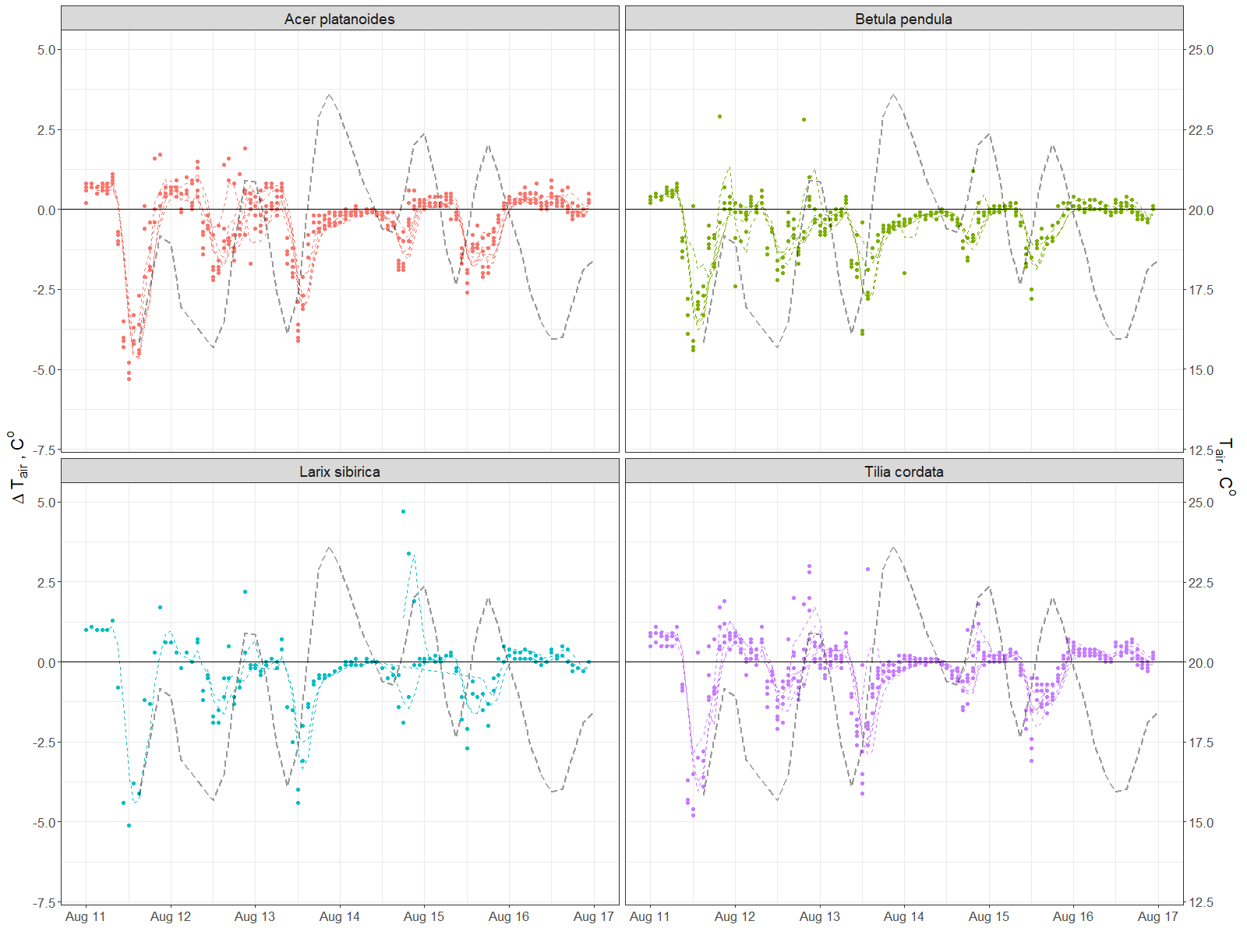

Annex 2. Daily and diurnal by month dynamics of the air relative humidity under and outside of the canopy

